Abstract
Background: Alzheimer’s disease (AD) is a complex and heterogeneous neurodegenerative disorder marked by variability in symptom onset and disease progression, complicating early detection and personalized care.
Objective: To address the need for early, individualized prognostication, we present the Alzheimer’s Disease Progression Grid (ADPG) Classifier, a deep learning framework that predicts longitudinal diagnostic transitions across cognitively normal (CN), mild cognitive impairment (MCI), and Alzheimer’s dementia (AD) stages over a 24-month horizon using only baseline data.
Methods: Leveraging a multimodal dataset comprising 5,593 visits from 1,562 unique subjects from the Alzheimer’s Disease Neuroimaging Initiative (ADNI), the ADPG Classifier integrates imaging, cognitive testing, plasma and CSF biomarkers, and APOE4 genotyping. The model architecture, Alzheimer’s Progression Network (AlzProgNet), employs grouped categorical cross-entropy (GCE) loss and an ensemble of 25 networks to produce 12-dimensional probabilistic outputs across four timepoints (T0, T6, T12, T24). Predictions are visualized using a 4×4 color-coded grid with confidence scores, enhancing interpretability.
Results: The ADPG Classifier achieved 97.02% accuracy for stable diagnostic states and 72.77% for transitioning cases. Notably, it anticipated future conversions months in advance in several subjects, with predictions aligning with later clinical confirmation. Compared to the ML4VISAD model, ADPG reduced computational complexity while improving predictive accuracy, temporal resolution, and uncertainty quantification.
Conclusion: By integrating multimodal baseline data with interpretable longitudinal forecasting, the ADPG Classifier offers a scalable and clinically actionable tool for personalizing AD care. Future work will incorporate graph-based and attention-driven models to enhance resilience to missing data and capture intermediate disease trajectories more precisely.
Introduction
Alzheimer’s disease (AD), the most common form of dementia among individuals aged 65 and older, accounts for approximately 60–70% of all dementia cases worldwide (World Health Organization [WHO], 2023; Rajan et al., 2021, Alzheimer’s Association, 2024). Clinically, AD is characterized by progressive cognitive decline, particularly in memory and executive functioning, often accompanied by personality changes and impaired judgment (Jack et al., 2018). The pathological hallmarks of AD—extracellular amyloid-β (Aβ) plaques and intracellular tau neurofibrillary tangles—lead to synaptic dysfunction and neurodegeneration, prominently affecting the hippocampus, entorhinal cortex, and fusiform gyrus (Braak & Braak, 1991; Hardy & Selkoe, 2002).
Importantly, a growing body of evidence indicates that AD pathology may begin to accumulate decades before clinical symptoms become apparent (Bateman et al., 2012). Longitudinal biomarker studies have demonstrated that amyloid-β (Aβ) deposition can start in the brain many years prior to measurable cognitive decline, marking the preclinical stage of Alzheimer’s disease. For instance, Bateman et al. (2012) showed that individuals genetically predisposed to familial AD exhibit detectable changes in amyloid biomarkers up to 20 years before symptom onset. More recent work by Janelidze et al. (2020, 2021) has extended these findings by identifying plasma phospho-tau species (p-tau181 and p-tau217) as sensitive indicators of early tau pathology, which closely correlate with tau accumulation detected by PET imaging and predict progression toward clinical dementia. In support of these findings, Long et al. (2022) demonstrated that preclinical AD biomarkers can robustly predict both cognitive decline and neuropathological outcomes, reinforcing the prognostic value of early biomarker detection in asymptomatic individuals. Furthermore, plasma biomarkers provide a minimally invasive method to track these neuropathological changes over time, enabling earlier identification of individuals at risk and improving opportunities for timely intervention. This extended preclinical window underscores the need for robust longitudinal models that integrate multimodal biomarker data to better understand disease progression and optimize therapeutic strategies before irreversible neurodegeneration occurs.
The progression of Alzheimer’s disease (AD) follows an uncertain trajectory with highly variable progression rates between patients. Several longitudinal studies have demonstrated the variability in disease progression across different stages—cognitively normal, preclinical AD, mild cognitive impairment (MCI), and AD dementia, underscoring the complexity of modeling individualized progression timelines. This makes predicting the conversion timeline particularly challenging. Recent work has highlighted the promise of integrating longitudinal neuroimaging/electroencephalogram and clinical data using deep learning architecture such as attention-based recurrent neural networks, which capture temporal dynamics and improve predictive performance (Olaimat et al., 2025; Ramalingam et al., 2024; Khosravi et al., 2024). Disease progression modeling frameworks have also been proposed to chart transitions across preclinical and clinical stages, offering a data-driven approach to staging and individualized prognosis (Cho et al., 2021). Recent evidence has shown that some individuals may bypass the MCI stage entirely and progress directly from normal cognition to Alzheimer’s dementia, further complicating standard disease modeling assumptions (Lu et al., 2024). Hospital-based cohort analyses further reveal substantial heterogeneity in MCI-to-AD conversion rates (Cheng et al., 2023; Thaipisuttikul et al., 2022, Landau et al., 2010), suggesting a need for models tailored to patient-specific factors. Genetic variation has also been shown to influence neuroanatomical aging trajectories, modulating individual risk profiles (Gifford et al., 2022). Furthermore, longitudinal cohort studies confirm that a significant portion of amyloid-positive individuals without clinical dementia eventually progress, reinforcing the predictive relevance of amyloid PET positivity (Roberts et al., 2018). Imaging studies also demonstrate that amyloid-positive MCI individuals show faster deterioration across clinical and biomarker domains compared to amyloid-negative peers (Ye et al., 2018). Multimodal feature fusion, particularly using PET and MRI data, has proven beneficial in stratifying risk and improving early prediction models (Zhou et al., 2024). Altogether, these insights support a paradigm shift toward individualized, multimodal, and temporally aware modeling approaches in AD progression research.
Despite advances in diagnostic techniques, including MRI, amyloid- and tau-PET imaging, cerebrospinal fluid (CSF) assays, and the emergence of plasma biomarkers (e.g., p-tau217, p-tau181, and Aβ42:40 ratio), predicting when and how quickly a cognitively normal individual or a patient with mild cognitive impairment (MCI) will progress to Alzheimer’s dementia remains a critical challenge (Hansson, 2021; Palmqvist et al., 2023). Disease progression is highly heterogeneous, and longitudinal studies have consistently demonstrated substantial variability in conversion rates between clinical stages (Sperling et al., 2011; Weiner et al., 2023). For example, longitudinal FDG-PET imaging studies have linked reduced glucose metabolism in temporoparietal regions with worsening cognition and function in MCI and AD patients (Landau et al., 2010). Additionally, voxel-based morphometry of longitudinal MRI scans has illustrated progressive region-specific atrophy patterns during the transition from MCI to AD, particularly in medial temporal and parietal cortices (Whitwell et al., 2007). These imaging markers provide essential insights into neurodegeneration and disease evolution. Recent work evaluating the revised criteria for biological and clinical staging of Alzheimer’s disease, which incorporate tau PET as a core biomarker, has highlighted persistent discrepancies between biological staging and clinical symptoms, emphasizing the challenges of translating biomarker-based criteria into routine clinical practice (Binette et al., 2025). Complementing these findings, a generalizable data-driven model developed by Baumeister et al. (2024) further illustrates the pronounced heterogeneity of atrophy patterns and disease progression in real-world memory clinic populations, reinforcing the need for personalized, data-driven staging frameworks.
In recent years, machine learning (ML) has emerged as a transformative approach for modeling AD progression by uncovering patterns in high-dimensional, multimodal datasets (Wen et al., 2022; Vogel et al., 2023). However, the majority of existing models focus on single-horizon predictions—offering a snapshot of future state rather than a full trajectory (Lu et al., 2022). Moreover, these models often lack interpretability and provide limited information about uncertainty, limiting their utility in clinical decision-making (Nguyen et al., 2023). Novel visualization techniques using nonlinear dimensionality reduction have shown promise for representing AD progression trajectories in more interpretable, low-dimensional spaces (Seo et al., 2019).
To address these limitations, we propose an enhanced and interpretable machine learning framework, termed the ADPG Classifier, which builds on the AlzProgNet architecture—a derivative of the ML4VISAD model originally introduced by Eslami et al. (2023). Their pioneering model represented two-year AD progression using two-dimensional, color-coded visualizations that captured regions of diagnostic uncertainty. While innovative, ML4VISAD was hindered by several shortcomings, including poor performance on transitioning diagnostic cases, checkerboard artifacts caused by up-sampling operations, and low interpretability due to sparse predictions within a 23×5 pixel matrix. Additionally, reliance on subjective human rater interpretation introduced potential bias and limited reproducibility.
Here, we propose an enhanced and interpretable “ADPG Classifier” framework based on the AlzProgNet model. This work builds upon and extends the significance of notable work published by Eslami et al. [14]. Authors of this study introduced ML4VISAD, a deep learning model, that transformed the baseline data into two-dimensional color-coded images representing two years of the disease progression with "regions of uncertainty”. Despite the foundational work and innovative approach to predict progression using deep learning techniques, the method exhibited several limitations. The model effectively generalized stable diagnostic classes but struggled to capture the transitioning cases accurately, mainly due to the outnumbered stable cases (934 subjects: 329 normal, 442 MCI, and 181 AD) compared to the 189 converter cases (8 MCI to CN and 181 MCI to AD). Furthermore, the generated output image lacked intuitive interpretability, as the diagnosis prediction for each time point was sparse over a 23 × 5-pixel matrix, leading to ambiguous visual cues in many cases where multiple diagnostic classes were present for the same period. The convolution and up-sampling operations further contributed to the ambiguity by producing a checkerboard effect. Additionally, the evaluation methodology implemented to assess the visualized output involved three human raters, which could lead to potential subjective bias and reduced clinical reproducibility due to the lack of standardized interpretation criteria.
The ADPG Classifier advances this work by integrating probabilistic, multi-horizon predictions across four clinically relevant time points (baseline, 6, 12, and 24 months) and offering intuitive outputs. Each prediction is visualized as a 4×4 color-coded grid that represents diagnostic class probabilities and is augmented by a confidence score derived from model uncertainty using a 25-model ensemble. This visual and numerical output provides a richer, more actionable summary of the disease trajectory. Notably, our model requires only a single time point of multimodal baseline data—encompassing structural MRI, cognitive assessments, CSF biomarkers, and APOE genotyping—making it both efficient and scalable in clinical settings. Recent advances in multimodal feature learning combining PET and MRI have demonstrated improved diagnostic accuracy, underscoring the value of such integrated approaches (Yu et al., 2023).
By combining longitudinal prediction, multimodal integration, and uncertainty quantification, the ADPG Classifier offers a novel and practical solution for personalized disease monitoring in Alzheimer’s care. This work aims to enhance clinical decision-making, reduce redundant diagnostic procedures, and inform individualized therapeutic interventions.
The core innovation of our work lies in its ability to deliver interpretable, personalized, and temporally dynamic predictions of Alzheimer’s disease progression through the following three key contributions:
- Multi-horizon & multi-state prediction: Our model performs multi-horizon, multi-state prediction by generating a stage-specific probability vector across four key timepoints—baseline (T0), 6 months (T6), 12 months (T12), and 24 months (T24). This enables clinicians to anticipate the likely trajectory of disease evolution and tailor interventions accordingly.
- Confidence Score: To enhance decision-making confidence, our AlzProgNet framework incorporates an ensemble of 25 models to estimate epistemic uncertainty, which is then translated into a confidence score—a critical step toward fostering trust and reliability in real-world clinical applications.
- ADPG Classifier framework: The ADPG Classifier transforms these predictions into an intuitive 4×4 color-coded grid, visually encoding both the temporal progression and model certainty. This compact yet informative representation supports clinical interpretation and facilitates patient-specific planning.
Dataset and cohort selection
We utilized the ADNIMERGE dataset from the Alzheimer’s Disease Neuroimaging Initiative (ADNI) to manually curate a working dataset tailored to our study objectives (ADNI, 2024). This dataset includes longitudinal, multimodal diagnostic data from a cohort of 2,155 subjects, encompassing a total of 13,915 time-stamped clinical observations. Each observation is categorized into one of three diagnostic classes: cognitively normal (CN), mild cognitive impairment (MCI), or Alzheimer’s disease (AD).
Our initial selection criterion focused on subjects with at least two years of longitudinal follow-up. From this pool, we further filtered subjects who had the most complete set of baseline (VSCODE = m0) multimodal features, as listed in Table 5. To ensure robust temporal labeling, we prioritized subjects with available diagnostic classifications at four key time points: baseline (m0), 6 months (m6), 12 months (m12), and 24 months (m24). Additionally, we included subjects with partially missing diagnostic labels at these time points when the missing labels could be reliably inferred. For example, if a subject was labeled as CN at m0, m12, and m24, the missing m6 label was inferred as CN. Likewise, if a subject was diagnosed with AD at both m0 and m6 and had no subsequent data, m12 and m24 were imputed as AD, reflecting the low likelihood of clinical reversion from AD to MCI.
For clarity, we denote the four diagnostic time points as T0 (m0), T6 (m6), T12 (m12), and T24 (m24). Table 1 summarizes the diagnostic class distribution across these time points for the 1,521 subjects ultimately included in our study.
Table 1: Initial Distribution of Diagnostic Classes
Diagnosis | T0 | T6 | T12 | T24
CN | 445 | 442 | 454 | 453
MCI | 707 | 668 | 591 | 490
AD | 369 | 411 | 476 | 578

Dataset Augmentation via Dynamic Baselines
We introduced a refactored baseline approach to expand the dataset further. Subjects with observations at different temporal points, other than m0, were considered a new baseline (T0) if they met the criteria defined in the initial cohort. Diagnostic follow-up labels were either available or could be interpreted at 6, 12, and 24 months after the observation timepoint. The subject’s age at the refactored baseline still reflected the age of the original baseline; hence, we adjusted the age to match the observation point. For example, suppose a subject aged 83.5 at baseline (m0) had most of the diagnosis data at m12 and subsequent labels at m18, m24, and m36. In that case, observation at m12 is a new refactored baseline (T0) with an adjusted age of 84.5, and corresponding observations at m18, m24, and m36 are mapped to T6, T12, and T24, respectively. We were able to substantially expand our dataset to 5,593 observation data points at T0 from 1,562 subjects, with a median of three data entries per subject, through this strategy. Table 2 provides a detailed breakdown of the expanded dataset for different diagnosis classes at the refactored baseline and follow-up evaluations.
Table 2: Distribution of Diagnostic Classes on the Extended Dataset
Diagnosis | T0 | T6 | T12 | T24
CN | 1373 | 1374 | 1386 | 1370
MCI | 2033 | 1856 | 1712 | 1520
AD | 2187 | 2363 | 2495 | 2703

One of the significant advantages of an expanded dataset is the increased representation of transition cases, which are essential for learning meaningful disease progression. Table 3 outlines the convertible cases for normal to mild cognitive (CN → MCI), normal to dementia (CN → AD), and mild cognitive to dementia (MCI → AD), as well as reverse conversion cases for mild cognitive to normal (MCI → CN) and dementia to mild cognitive (AD → MCI) between initial cohort selection and extended dataset.
Table 3: Transition Cases Between Consecutive Timepoints
Converters | T0 -> T6 |  | T6 -> T12 |  | T12 -> T24
Converters | Initial | Expanded | Initial | Expanded | Initial | Expanded
CN → MCI | 11 | 11 | 8 | 9 | 18 | 64
CN → AD | 0 | 0 | 0 | 0 | 0 | 3
MCI → CN | 8 | 12 | 20 | 21 | 17 | 51
MCI → AD | 45 | 182 | 68 | 136 | 106 | 214
AD → MCI | 3 | 6 | 3 | 4 | 4 | 9
Table 4 characterizes the dataset’s distribution based on stability and conversion status by comparing the diagnosis group at baseline (T0) with the rest of the predictive period. The subject is considered stable if the diagnosis class through T0 to T24 remains the same; if it transitions from one class to another at any time point, it is classified as a convertible case. Each diagnosis class is divided into stable or convertible groups.
Table 4: Diagnostic Distribution by Longitudinal Stability
Status Group | Initial | Expanded | Remarks
CN | 415 | 1295 | Remained CN throughout 2 years
CNc | 30 | 78 | CN at T0 converted to MCI/AD within 2 years
MCI | 458 | 1434 | Remained MCI throughout 2 years
MCIc | 249 | 599 | MCI at T0 converted to CN/AD within 2 years
AD | 365 | 2176 | Remained AD throughout 2 years
ADc | 4 | 11 | AD at T0 converted to MCI within 2 years
The dataset was classified into five modalities based on the diagnostic procedures for data retrieval:
- MRI: Volumetric measurements of brain regions extracted from Magnetic Resonance Imaging.
- PET: Features extracted from Positron Emission Tomography (PET) imaging.
- COG: Scores from cognitive and functional assessments
- CSF: Biomarkers derived from CSF fluid analysis
- RF: Clinical risk factors that directly or indirectly contribute to the progression of AD
MRI Modality (MRI): The structural MRI-derived features comprise volumetric measurements of the ventricles, hippocampus, entorhinal cortex, fusiform gyrus, middle temporal lobe, and whole brain, all of which are known to undergo neuropathological changes associated with Alzheimer's disease. A comprehensive literature review of longitudinal MRI has documented progressive atrophy involving these regions, concurrent with the expansion of ventricles across the AD continuum, compared to age-associated changes alone (Whitwell, 2010; Lee et al., 2023). Regional and global brain atrophy are associated with the presence of amyloid immunoreactive senile plaques and tangles (Whitwell, 2010).
The volumetric MRI features were normalized by intracranial volume (ICV). Figure 1 illustrates the ICV-normalized distribution of MRI features and the counts of missing values across diagnostic groups. The distribution exhibits a predictable pattern of progressive volume reduction in cortical and subcortical regions across the diagnostic stages, accompanied by concomitant enlargement of the ventricles.
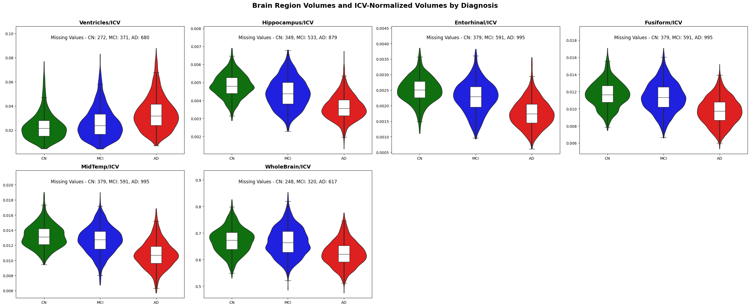
Figure 1: Distribution of Normalized Features for MRI Modality by diagnosis class
PET Modality (PET): The PET modality includes two radio-traced features retrieved through Positron Emission Tomography (PET) imaging, which measure Fluorodeoxyglucose (FDG) and Florbetapir (AV-45) biomarkers. FDG-PET, labeled with radioactive fluorine-18 (¹⁸F), measures glucose metabolism to reflect neuronal activity in the brain. It is susceptible to hypometabolism, often reported in pre-AD cases. This makes PET a strong diagnostic indicator of MCI patients at greater risk of AD (Marcus et al., 2014). Florbetapir (AV-45) is a radioligand and amyloid imaging agent that targets and selectively binds with amyloid-beta plaques for non-invasive visualization and quantification (Marcus et al., 2014; Rice & Bisdas, 2017). Figure 2 illustrates the distribution of FDG and AV-45 across different diagnostic categories, highlighting the AD-associated inverse relationship between declining metabolic activity and increasing amyloid plaque.
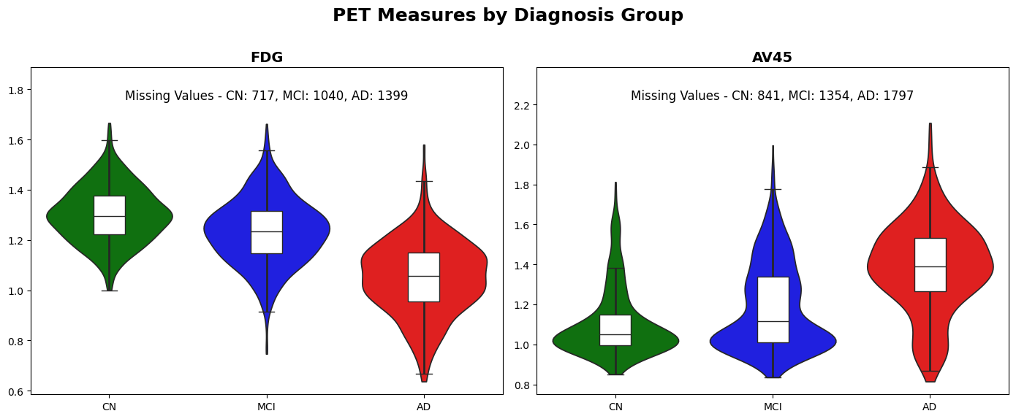
Figure 2: Distribution of Features for PET Modality by Diagnosis Class
Cognitive Assessment Modality (COG): We selected 11 distinct neuropsychological test scores, making the Cognitive Assessment Modality the one with the highest number of features among others. A systematic review of 57 studies evaluating the effectiveness of cognitive tests individually found that many tests were highly sensitive in distinguishing AD from normal. In contrast, these tests were limited in differentiating AD from MCI (Hemmy et al., 2020). Hence, we included multiple test scores to identify patterns of distinct aspects of cognition (staging, memory functionality, executive capabilities, and functional impact) across the diagnostic continuum. Figure 3 highlights the distribution and tendency of each test score by diagnosis stage, visualizing the progressive decline in cognitive and functional performance.
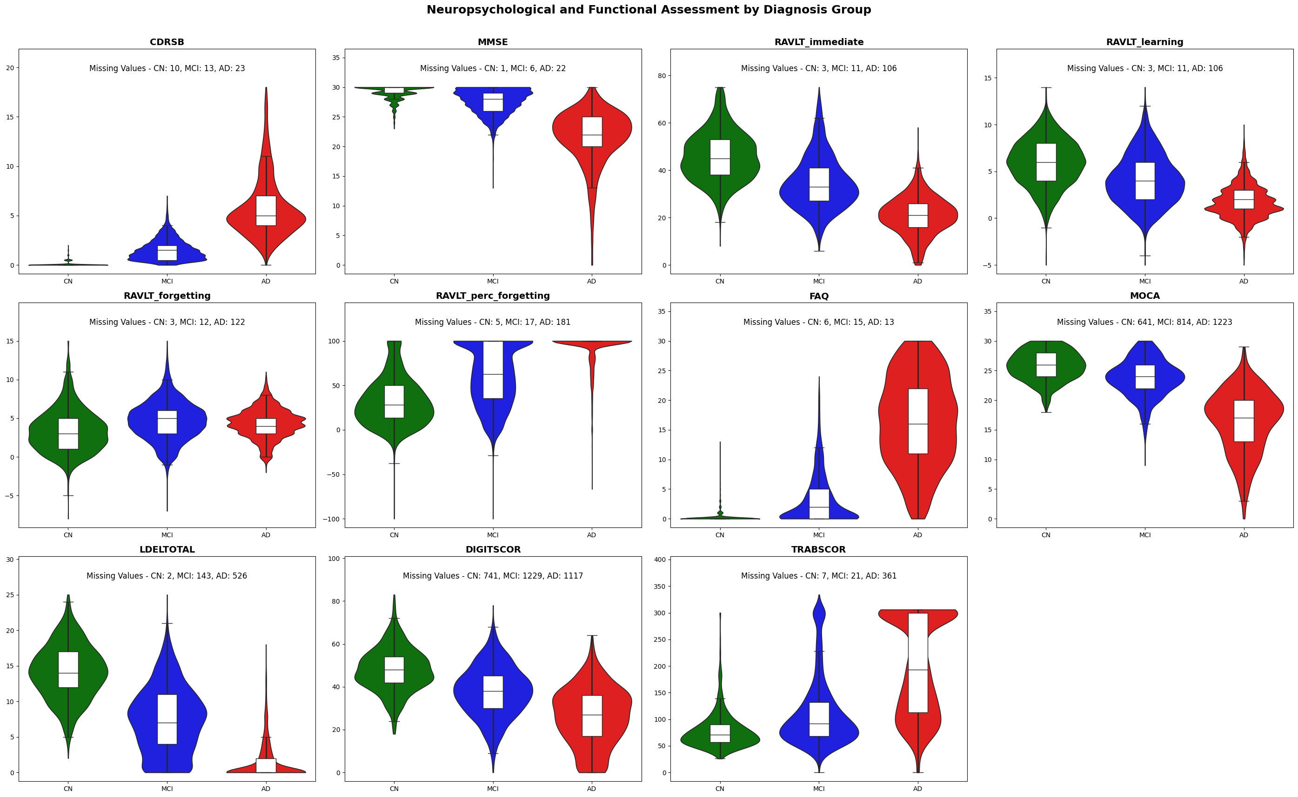
Figure 3: Distribution of Neuropsychological and Functional Assessment Features for COG Modality by diagnosis class
CSF Biomarkers Modalities (CSF): Cerebrospinal fluid is a translucent bodily fluid that circulates through the ventricular system and subarachnoid space of the brain and spinal cord and contains disease-relevant proteins and metabolites. The three core biomarkers Aβ1–42 (ABETA), phosphorylated tau (PTAU), and total tau (TAU) found in CSF exhibit strong correlations with AD pathology and assist in detecting disease stage and progression, including differentiating AD from non-AD dementia, and determining the chances of MCI to AD conversion (Anoop et al., 2010). ABETA measures levels of Aβ1–42 peptide sequestered in cerebral plaques, which decrease with AD progression. PTAU measures tau protein associated with the formation of neurofibrillary tangles and shows a positive correlation with cognitive decline. TAU increases as the response to axonal damage and cell death and reflects the extent of general neuronal injury (both AD and non-AD).
There were a few observations in CSF features that were reported as a range, indicating values below or above the quantification limits of the assay. These censored values were transformed to their respective threshold boundaries to ensure consistency with the dataset. For the ABETA biomarker, values reported as <200 and >1700 were recorded as 200 and 1700, respectively. Similarly, Tau values denoted as <80 and >1300 were clipped to 80 and 1300, respectively. For PTAU, values indicated as <8 and >120 were reassigned as 8 and 120, respectively. Figure 4 presents the biomarker concentrations at baseline (T0) across the diagnostic groups.
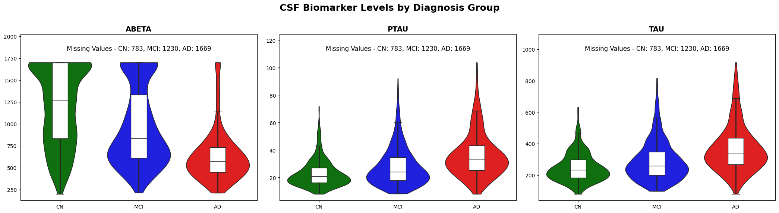
Figure 4: Distribution of Features for CSF Modality by diagnosis class
Risk Factor Modality (RF): The final input modality captures key demographic and genetic variables that influence onset and progression. These include age, educational attainment (PTEDUCAT), APOE4 genotype, and gender (PTGENDER). The risk of developing AD increases substantially after the age of 65. Individuals carrying one APOE ε4 allele have 2-3-fold increased risk, while homozygous carriers have 10-15-fold increased risk of developing AD (Troutwine et al., 2022). Studies have reported that higher educational attainment modulates performance on cognitive tests and delays the clinical onset of disease due to greater cognitive reserve, despite pathological indications (Rosselli et al., 2022). Similarly, epidemiological studies report higher AD prevalence in women, potentially due to longer life expectancy, hormonal factors, and differential brain reserve, but this remains an area of active research (Mielke, 2018). Figure 5 visualizes the distribution and trends of risk factors and demographic factors in our dataset, providing orthogonal information to other modalities.
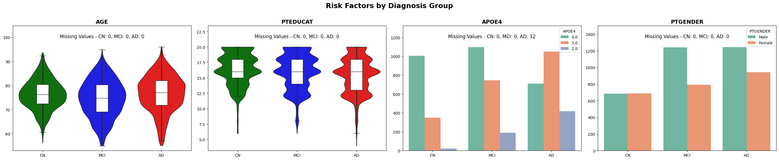
Figure 5: Distribution of Features for RF Modality by Diagnosis Class
Data Pre-processing
The dataset underwent two key preprocessing steps: data imputation to address missing values and data normalization to standardize feature scales.
- Data Imputation:
While the extended dataset increased cohort size, it concurrently introduced a higher proportion of missing values—the total number of missing values per feature before imputation is provided in Table 5. Missing data patterns are predominantly attributable to selective data acquisition protocols, patient burden reduction strategies, and resource allocation constraints associated with high-cost diagnostic procedures. To tackle and impute the missing values, we adopted a two-stage imputation technique that preserves progression trends and minimizes bias.
Subject-Specific Regression Imputation (SSRI): We applied regression to estimate missing values at T0 for a feature when a given subject-feature pair has at least three observed measurements in total (available before or after the baseline T0) at the ADNIMERGE dataset. We were able to impute 31.93% of the total missing values across all features. A detailed breakdown of imputation per feature is listed in Table 5. The available feature for a subject at temporal groups is represented by t = [t0, t1, t2, …], where $t_{i}$ corresponds to the numerical VISCODE, and i is the index of the observation point. If $t_{i}$ has a VISCODE of m24, then the value of $t_{i}$ is 24. Similarly, the feature value set for the corresponding observation points is represented by x = [x₀, x₁, x₂, …]. It is then fitted to an ordinary least squares model to estimate the slope α and intercept β.
$x= αt+ β$
The imputed value $\hat{x}$ for baseline $T0$ for a given subject-feature, it is then calculated by:
$$\hat{x }= α\hat{t}+ β$$
where $\hat{t}$ is the numerical value of VISCODE corresponding to T0.
For example, suppose subject has a missing value for Feature X at T0, where T0 corresponds to VISCODE m12 and has observed values at m0, m6, m24, and m48. In that case, the “Subject-Specific Regression Imputation” technique is used in estimating the missing value for Feature X.
Diagnosis-Specific Mean Imputation (DSMI): For the remaining missing values at baseline that did not meet the criteria for regression imputation, we applied mean imputation stratified by diagnostic class. We have three classes for the diagnostic class: CN, MCI, and AD. Hence, we calculated the average of each feature per class from the dataset that had undergone subject-specific regression imputation and applied the average value for the missing values for the feature-class pair. The average value for each feature-class pair is presented in Table 5, along with the Q1, Q2, and Q3 distributions.
Table 5 summarizes the results from both imputation processes by each feature of the dataset. The column “Imputed by SSRI” represents the imputation count from regression imputation, while the column “Imputed by DSMI” represents the imputation count from mean imputation.
Table 5: Imputation Summary by Modality, Feature, and Diagnostic Stage
Modality | Feature | Missing Values | Imputed by SSRI | Feature Values After SSRI |  |  |  |  | Imputed by DSMI
 |  |  |  | Stage | Mean | Q1 | Q2 | Q3 | Imputed by DSMI
MRI | Ventricles | 1323 | 1005 | CN | 0.0231 | 0.015 | 0.0214 | 0.0279 | 318
 |  |  |  | MCI | 0.0261 | 0.0166 | 0.0238 | 0.0332 | 318
 |  |  |  | AD | 0.0339 | 0.024 | 0.0318 | 0.0416 | 318
MRI | Hippocampus | 1761 | 1129 | CN | 0.0048 | 0.0044 | 0.0048 | 0.0053 | 632
 |  |  |  | MCI | 0.0044 | 0.0038 | 0.0044 | 0.005 | 632
 |  |  |  | AD | 0.0036 | 0.0031 | 0.0035 | 0.004 | 632
MRI | MidTemp | 1965 | 1127 | CN | 0.0132 | 0.0121 | 0.0131 | 0.0142 | 838
 |  |  |  | MCI | 0.0127 | 0.0115 | 0.0127 | 0.0139 | 838
 |  |  |  | AD | 0.0108 | 0.0096 | 0.0107 | 0.0118 | 838
MRI | Entorhinal | 1965 | 1127 | CN | 0.0025 | 0.0023 | 0.0025 | 0.0028 | 838
 |  |  |  | MCI | 0.0023 | 0.0019 | 0.0023 | 0.0026 | 838
 |  |  |  | AD | 0.0018 | 0.0014 | 0.0017 | 0.002 | 838
MRI | Fusiform | 1965 | 1127 | CN | 0.0117 | 0.0107 | 0.0116 | 0.0127 | 838
 |  |  |  | MCI | 0.0114 | 0.0102 | 0.0113 | 0.0125 | 838
 |  |  |  | AD | 0.0097 | 0.0087 | 0.0097 | 0.0108 | 838
MRI | WholeBrain | 1185 | 944 | CN | 0.6717 | 0.6383 | 0.6732 | 0.7025 | 241
 |  |  |  | MCI | 0.6663 | 0.6277 | 0.6637 | 0.706 | 241
 |  |  |  | AD | 0.6229 | 0.5906 | 0.6199 | 0.6528 | 241
PET | FDG | 3156 | 486 | CN | 1.3012 | 1.2234 | 1.2995 | 1.3766 | 2670
 |  |  |  | MCI | 1.2395 | 1.1536 | 1.2444 | 1.32 | 2670
 |  |  |  | AD | 1.0546 | 0.9544 | 1.0618 | 1.159 | 2670
PET | AV45 | 3992 | 780 | CN | 1.0955 | 0.9864 | 1.0366 | 1.1468 | 3212
 |  |  |  | MCI | 1.1764 | 1.0052 | 1.089 | 1.3256 | 3212
 |  |  |  | AD | 1.379 | 1.249 | 1.3814 | 1.5283 | 3212
COG | CDRSB | 46 | 40 | CN | 0.0771 | 0 | 0 | 0 | 6
 |  |  |  | MCI | 1.5465 | 0.5 | 1.5 | 2 | 6
 |  |  |  | AD | 5.8167 | 4 | 5 | 7 | 6
COG | MMSE | 29 | 25 | CN | 29.1164 | 29 | 29 | 30 | 4
 |  |  |  | MCI | 27.599 | 26 | 28 | 29 | 4
 |  |  |  | AD | 21.5009 | 20 | 22 | 25 | 4
COG | RAVLT_  immediate | 120 | 98 | CN | 45.9193 | 38 | 45 | 53 | 22
 |  |  |  | MCI | 34.7218 | 27 | 33 | 41 | 22
 |  |  |  | AD | 20.5401 | 16 | 21 | 26 | 22
COG | RAVLT_  learning | 120 | 98 | CN | 5.9334 | 4 | 6 | 8 | 22
 |  |  |  | MCI | 4.1468 | 2 | 4 | 6 | 22
 |  |  |  | AD | 1.6847 | 1 | 1.4833 | 3 | 22
COG | RAVLT_  forgetting | 137 | 107 | CN | 3.44 | 1 | 3 | 5 | 30
 |  |  |  | MCI | 4.6834 | 3 | 5 | 6 | 30
 |  |  |  | AD | 4.3004 | 3 | 4 | 5.4 | 30
COG | RAVLT_perc_  forgetting | 2023 | 150 | CN | 32.035 | 13.333 | 28.571 | 50 | 1873
 |  |  |  | MCI | 61.206 | 36.364 | 62.5 | 100 | 1873
 |  |  |  | AD | 93.198 | 100 | 100 | 100 | 1873
COG | FAQ | 34 | 27 | CN | 0.2173 | 0 | 0 | 0 | 7
 |  |  |  | MCI | 3.313 | 0 | 2 | 5 | 7
 |  |  |  | AD | 16.384 | 11 | 16.567 | 22 | 7
COG | MOCA | 2678 | 822 | CN | 26.1 | 24 | 26 | 28 | 1856
 |  |  |  | MCI | 24.095 | 22 | 24 | 26 | 1856
 |  |  |  | AD | 16.47 | 13 | 17 | 20 | 1856
COG | LDELTOTAL | 671 | 436 | CN | 14.122 | 12 | 14 | 17 | 235
 |  |  |  | MCI | 7.135 | 3 | 7 | 10 | 235
 |  |  |  | AD | 1.4466 | 0 | 0 | 2 | 235
COG | DIGITSCOR | 3087 | 794 | CN | 48.712 | 42 | 48.140 | 55.253 | 2293
 |  |  |  | MCI | 38.943 | 31 | 38.214 | 47 | 2293
 |  |  |  | AD | 26.947 | 17 | 28 | 38 | 2293
COG | TRABSCOR | 389 | 238 | CN | 78.559 | 57 | 71 | 90 | 151
 |  |  |  | MCI | 113.254 | 68 | 92 | 133 | 151
 |  |  |  | AD | 205.944 | 117 | 204 | 300 | 151
CSF | ABETA | 3682 | 493 | CN | 1203.81 | 831.3 | 1270 | 1689.26 | 3189
 |  |  |  | MCI | 972.99 | 613.35 | 845.8 | 1359.88 | 3189
 |  |  |  | AD | 634.83 | 445.05 | 567.55 | 735.45 | 3189
CSF | PTAU | 3682 | 492 | CN | 22.832 | 16.122 | 20.77 | 27.12 | 3190
 |  |  |  | MCI | 27.531 | 17.705 | 24 | 34.755 | 3190
 |  |  |  | AD | 35.537 | 24.387 | 32.477 | 42.163 | 3190
CSF | TAU | 3682 | 493 | CN | 247.464 | 183.3 | 232 | 299.7 | 3189
 |  |  |  | MCI | 287.978 | 198.1792 | 259.2 | 346.858 | 3189
 |  |  |  | AD | 362.404 | 258.574 | 332.3 | 428.9 | 3189
RF | AGE | 0 | 0 | CN | 76.322 | 72.4 | 76.3 | 80.4 | 0
 |  |  |  | MCI | 74.535 | 69.1 | 74.8 | 80.3 | 0
 |  |  |  | AD | 76.597 | 71.9 | 77.1 | 82 | 0
RF | PTEDUCAT | 0 | 0 | CN | 16.444 | 15 | 16 | 18 | 0
 |  |  |  | MCI | 15.986 | 14 | 16 | 18 | 0
 |  |  |  | AD | 15.441 | 13 | 16 | 18 | 0
RF | APOE4 | 0 | 0 | CN | 0.284 | 0 | 0 | 1 | 0
 |  |  |  | MCI | 0.5548 | 0 | 0 | 1 | 0
 |  |  |  | AD | 0.8657 | 0 | 1 | 1 | 0
RF | PTGENDER | 0 | 0 | - | - | - | - | - | 0

- Data Normalization:
To ensure consistency and reliability in the input data, we first removed outlier cases in the data selection phase subjects with extreme values or atypical progression patterns that deviated markedly from their expected diagnostic class. Moreover, despite this preprocessing and the application of a two-stage imputation strategy, the resulting feature distributions remained skewed and non-Gaussian. To address this, we applied min-max normalization, rescaling all features to a standard range between 0 and 1. Thus, for each observation $x$ for a given feature, the normalized value ${x'}_{ }$ was computed as follows:
$${x'}_{ }= \frac{x- x_{min}}{x_{max}- x_{min}}$$
where $x$ is the original feature value and $x_{min}$ and $x_{max}$ denote the minimum and maximum values of the feature within the training set. The normalization parameters ($x_{min}$and $x_{max}$) were computed exclusively from the training set, and the same transformation parameters were subsequently applied to test sets, thereby preventing data leakage, and preserving model integrity.
System Architecture
The proposed architectural framework comprises two core components tailored for the longitudinal prediction of Alzheimer's disease progression. The first component is an ensemble of fully connected deep learning models that ingests normalized, multimodal features at baseline (T0) and generates probabilistic predictions—along with associated epistemic uncertainties—for each diagnostic category (Cognitively Normal, MCI, and AD) at four successive timepoints: T0, T6, T12, and T24 months. The second component takes these outputs and restructures them into a grid-based format, encoding both class probabilities and epistemic uncertainties in a visually interpretable manner. This design enables clear visualization of disease trajectory predictions, offering clinicians an intuitive and temporal overview of likely progression patterns that are quantifiable.
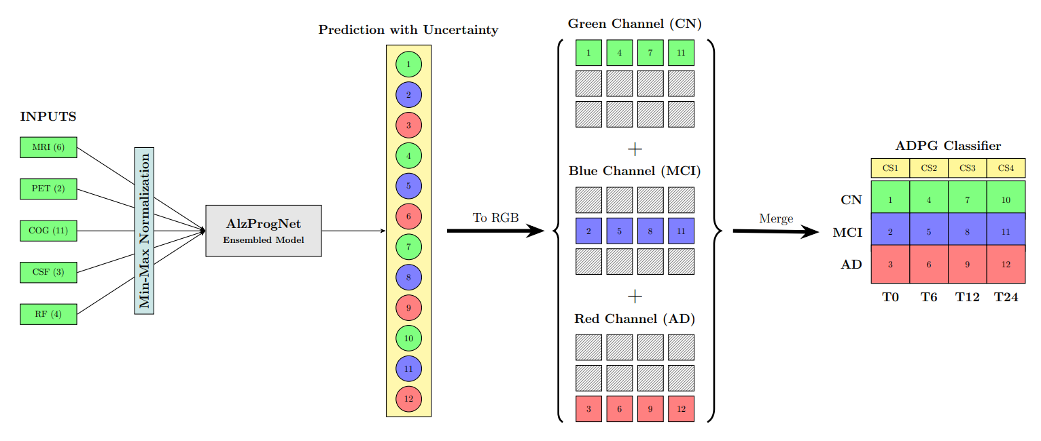
Figure 6: System Architecture for the ADPG Classifier for Visualizing Alzheimer’s Disease Progression
- Model Architecture:
The proposed network architecture, AlzProgNet, has a multi-branch fully connected network that ingests a normalized feature vector from 5 modalities as input to predict the AD progression as:
$$O_{prog}= Μ(I_{MRI}, I_{PET}, I_{COG}, I_{CSF}, I_{RF})$$
where $O_{prog}$ is the output vector of 12 nodes representing the probability of progression into CN, MCI, and AD at T0, T6, T12, and T24, estimated by the model $Μ$, and $I_{MRI}, I_{PET}, I_{COG}, I_{CSF}, I_{RF}$ are the feature vectors for MRI, PET, COG, CSF, and RF modalities, respectively. The model contains 26 total features distributed across five modalities. The feature order within each modality corresponds to the sequence presented in Table 5.
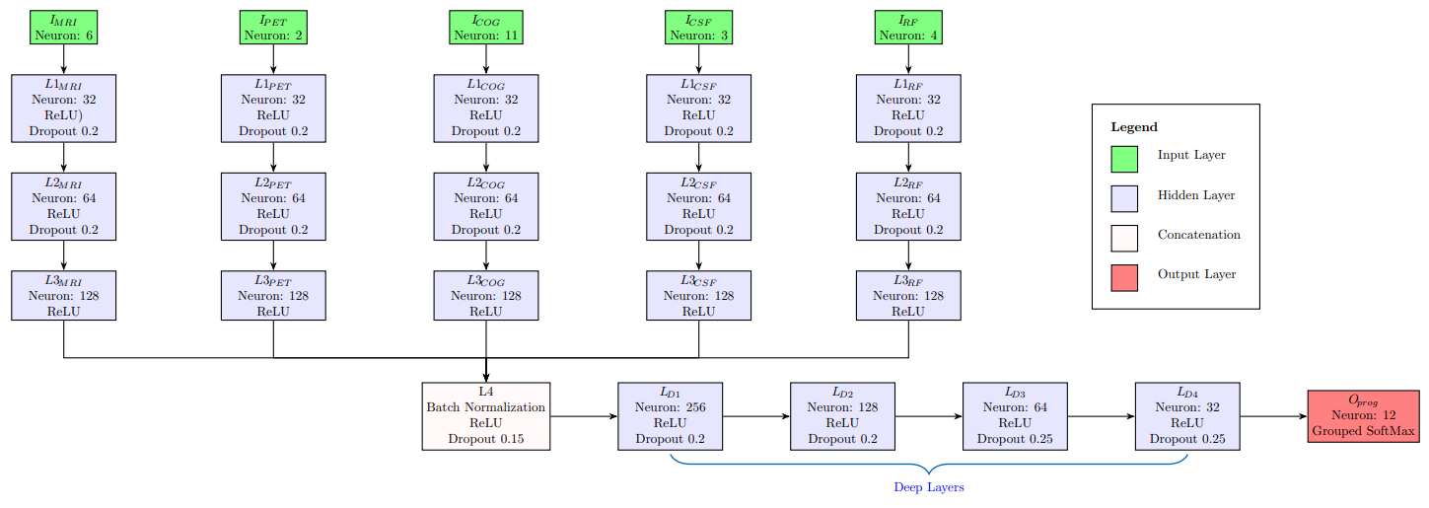
Figure 7: Model Architecture of Fully Connected Network, AlzProgNet
Each input modality passes independently through three progressively widening feedforward layers. The first layer, L1, connected to the input modality, has 32 nodes, followed by a ReLU activation function and a dropout rate of 20%. The ReLU activation introduces non-linearity, which helps the network learn complex patterns and maintain gradients during backpropagation. Meanwhile, dropout helps prevent overfitting by randomly deactivating neurons during training. The second layer, L2, upscales the representation to 64 neurons with a ReLU activation function and a dropout rate of 20%. The third layer, L3, further expands the modality-specific features space to 128 neurons and applies ReLU activation for regularization. The progressive upscaling of L1, L2, and L3 scale representation is to detect subtle patterns that may not be apparent at the original input scale.
The next layer, L4, concatenates the outputs from L3 for all five modalities to create a unified representation of the multimodal data. The concatenated feature vector with 540 nodes is then batch normalized to reduce internal covariate shift, stabilize the input distribution for subsequent layers, and accelerate convergence during training. Batch normalization computes a standard normal distribution with zero mean and unit variance on the concatenated output, independently for each mini-batch. The normalized output is then followed by ReLU activation, which restricts values to non-negative, and a dropout rate of 15% is applied to mitigate overfitting.
A funnel architecture with multiple deep layers transforms the output from L4 to the final output, $O_{prog}$ , through dimensional reductions and salient pattern extractions. The initial deep layer, L_{D1}, reduces the 640-dimensional vector from layer L4 to 256 neurons, followed by ReLU activation and a 20% dropout rate. The subsequent layer, L_{D2}, further minimizes the representation to 128 neurons using ReLU and the same dropout rate of 20%. The following two layers, L_{D3} and L_{D4}, funnel down the model to 64 and 32 neurons, respectively, and utilize ReLU activation with an increased dropout rate of 25%.
The final output layer $O_{prog}$ is structured with 12 neurons$y_{ini}= \{y₀, y₁, …., y_{11}\}$ and connected to the previous layer L_{D4}. The output is transformed into a probabilistic distribution of diagnostic class for each time point with Grouped-SoftMax. Grouped-SoftMax (GS) is a variant of traditional SoftMax that applies activation independently to non-overlapping, predefined neuron groups, rather than the entire output vector. The output tensor is portioned into four groups by diagnostic temporal period: g₀ = {y₀, y₁, y₂} for T0, g₁ = {y₃, y₄, y₅} for T6, g₂ = {y₆, y₇, y₈} for T12, and g₃ = {y₉, y₁₀, y₁₁} for T24. Each group corresponds to the raw output logits for three diagnostic states: CN (Cognitively Normal), MCI (Mild Cognitive Impairment), and AD (Alzheimer's Disease). We apply Grouped SoftMax to each group g_{i,} where $i∈ \left\{0, 1, 2, 3\right\}$:
$${\hat{Y}}_{j}=GS\left(y_{j}\right)= \frac{e^{y_{j}}}{\sum_{k=0}^{2}{e^{y_{3i+k}}}} for each j∈ \left\{3i, 3i+1, 3i+2\right\}$$
This ensures that each group ${\hat{G}}_{i}=\{{\hat{Y}}_{3i},{\hat{Y}}_{3i+1},{\hat{Y}}_{3i+2}\}$sums up to 1 and forms a valid probability distribution over each diagnostic class. The complete probabilistic output $Y_{pred}$ is obtained by:
$$Y_{pred}= GS\left(y_{ini}\right)= \left[{\hat{G}}_{o}, {\hat{G}}_{1}, ​{\hat{G}}_{2}, {\hat{G}}_{3}\right]=[\hat{Y}₀,\hat{ Y}₁, …., {\hat{Y}}_{11}]$$
The model has a total of 263,436 parameters to learn nuanced representations for disease progression prediction, with 262,156 parameters that include weights and biases in the fully connected layers that are optimized via backpropagation during the training phase to minimize the loss function. The remaining 1280 parameters are non-trainable, resulting from the batch normalization implemented in layer L4, which maintains moving averages of the mean and variance for each node during training.
- Training and Evaluation
The categorical diagnosis class labels were encoded using one-hot encoding such that CN was represented as [1, 0, 0], MCI as [0, 1, 0], and AD as [0, 0, 1] for each group. For each subject, a target vector $Y_{true}$was constructed by concatenating one-hot encoded vectors corresponding to each of the temporal groups $G_{i}=\{Y_{3i},Y_{3i+1},Y_{3i+2}\}$ to form a unified 12-dimensional tensor:
$$Y_{true}=\left[G_{o}, G_{1}, ​G_{2}, G_{3}\right]=[Y₀,Y₁, …., Y_{11}]$$
Firstly, to assess the model’s capability and stability in predicting the transition, we used 10-fold cross-validation, where each fold had a data distribution of 81/9/10 for training, validation, and testing, respectively. The Adam optimizer, combined with a modified cross-entropy loss function, helped optimize the model's performance. Given that the model produces four independent probability distributions, the standard categorical cross-entropy function, treating the output vector as a single probability distribution, was not suitable for our case. Hence, we developed Grouped Categorical Cross-Entropy (GCCE) that computes loss per sample as an average of individual cross-entropy over the temporal groups, and mathematically is expressed as:
$$L_{GCCE}= \frac{1}{4}\sum_{i=0}^{3}{\left(-\sum_{k=0}^{2}{ Y_{3i+k}. \log\left({\hat{Y}}_{3i+k}\right)}\right)}$$
Where the outer sum runs over the four diagnostic time groups, the inner sum runs over the three diagnostic states for each group, Y is a true tensor, and $\hat{Y}$ is a predicted tensor.
The model was trained with a batch size of 64 over 600 epochs but utilized a learning rate scheduler and early stopping to reduce training time. The learning rate scheduler monitored the validation loss. It reduced the learning rate (LR) by 10% if no improvement was observed over 10 consecutive epochs, until the LR reached the lower bound of 10⁻⁶. Early stopping terminated the training and restored the best weights with the lowest validation loss when the validation loss did not improve within 50 epochs.
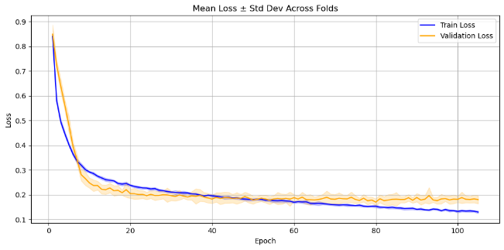
Figure 8: Training and validation performance over epochs
Figure 8 illustrates stable convergence and consistent improvement during training and validation. The solid line represents the average value, while the shaded areas represent the range between maximum and minimum observed values at each epoch. The model achieved an average loss of 0.1737 ± 0.0285 on the independent test set, as determined by 10-fold cross-validation.
- Ensembled Output
We implemented ensemble learning (El-sappagh et al., 2022; Rokach, 2010; Pan et al., 2020; Ortiz et al., 2016) using 25 independently trained models, all of which shared the same training set, to enhance predictive accuracy and quantify uncertainty. The dataset first reserved 9 subjects exclusively for test set to ensure comparability with prior work. Afterwards, the remaining data were randomly divided into training, validation and testing with a ratio of 81:9:10 respectively. Following dataset portioning, min-max normalization was applied for feature normalization wherein the scaling parameters were fitted on the training set and subsequently applied to transform to both the validation and test sets. Each model in the ensemble was trained using same training and validation sets, but with randomized weight initialization and data shuffling. The ensemble inference procedure resulted in a prediction array of shape 12 X 25 (12-dimentional predictions from 25 models). This matrix was further aggregated to form the final ensemble output consisting of two arrays: the first array contains the predicted probabilities for each diagnostic class within each temporal group, and the second array provides the corresponding uncertainty estimates for these predictions. The ensemble prediction ($Y_{ensemble}$) is computed as the arithmetic mean of all constituent model outputs:
$$Y_{ensemble}=\frac{1}{N}\sum_{i=1}^{N}{Y_{pred,i}= \left[{\tilde{G}}_{o}, {\tilde{G}}_{1}, ​{\tilde{G}}_{2}, {\tilde{G}}_{3}\right]= [\tilde{Y}₀,\tilde{ Y}₁, …., {\tilde{Y}}_{11}]}$$
Where N=25 represents the number of models in the ensemble and $Y_{pred,i}$ is the prediction from the i^{th} model.
${\tilde{G}}_{i}=\{{\tilde{ Y}}_{3i},{\tilde{ Y}}_{3i+1}, {\tilde{ Y}}_{3i+2}\}$ is the temporal group containing the probability of the ensemble prediction.
The reliability of the ensemble prediction is measured by epistemic uncertainty, which estimates confidence in the model’s predictions. The uncertainty ($U_{ensemble})$ is measured by calculating the variance across the ensemble output.
$$U_{ensemble}= σ^{2}= \frac{1}{N-1}\sum_{i=1}^{N}{{(Y_{pred,i}- Y_{ensemble})}^{2}=\left[{\tilde{g}}_{o}, {\tilde{g}}_{1}, ​{\tilde{g}}_{2}, {\tilde{g}}_{3}\right] =[\tilde{U}₀,\tilde{ U}₁, …., {\tilde{U}}_{11}]}$$
${\tilde{g}}_{i}=\{{\tilde{ U}}_{3i},{\tilde{ U}}_{3i+1}, {\tilde{ U}}_{3i+2}\}$ is the temporal group containing uncertainty of the ensemble prediction. Higher uncertainty values indicate greater disagreement in the ensemble prediction, signaling out-of-distribution samples or challenging diagnostic scenarios.
- Visualization Framework
Visualization techniques have played a pivotal role in advancing our understanding of Alzheimer’s disease (AD) progression, particularly in the context of longitudinal imaging studies. Whitwell et al. (2007) employed 3D voxel-based morphometry on longitudinal MRI data to create detailed brain maps illustrating region-specific atrophy as individuals transitioned from mild cognitive impairment (MCI) to AD. Their results highlighted progressive degeneration in the medial temporal lobe, parietal cortex, and posterior cingulate, offering spatial biomarkers critical for early detection. Building upon such structural insights, Yu et al. (2023) proposed a deep multimodal feature learning framework that integrates MRI and PET data to enhance diagnostic accuracy. By preserving both global and local information across modalities, their joint model significantly outperformed unimodal approaches, demonstrating the power of fused imaging for comprehensive disease monitoring. Seo et al. (2019) contributed a complementary method using Locally Linear Embedding (LLE) to visualize patient trajectories within a low-dimensional manifold constructed from multimodal and clinical data. This approach captured nonlinear and heterogeneous transitions across diagnostic stages, enhancing interpretability of individual progression patterns. More recently, Malepathirana et al. (2023) developed a dynamic visualization strategy using incrementally learned low-dimensional projections (incremental Isomap and PCA) to map longitudinal disease trajectories as new patient data becomes available. Their method is especially well-suited to clinical applications, enabling real-time visualization of subject-specific and cohort-level changes without retraining on the full dataset. Collectively, these approaches underscore the growing importance of advanced visualization in decoding the complex and individualized pathways of AD progression.
In this study, taking a totally different approach, we designed a visualization framework, the Alzheimer’s Disease Progression Grid (ADPG) Classifier, which transforms the ensemble output into an intuitive 4x4 color-coded grid to facilitate the visualization and interpretability of disease progression over two years. Figure 9 shows representative examples that were generated by reshaping the model’s output into a structured grid format. The first three subfigures (a-c) illustrate the stable cases of CN, MCI, and AD, respectively, over two years. Similarly, subfigures (d-e) exemplify the converter cases of CN to MCI and MCI to AD. The first row represents the model’s confidence scores on the predicted probability distribution, while the remaining three rows depict the diagnostic stages of CN, MCI, and AD. The four columns represent the temporal groups at baseline (T0), 6 months (T6), 12 months (T12), and 24 months (T24). The grid utilizes RGB color channels to visually differentiate the diagnostic classes, where the green channel represents CN, the blue channel corresponds to MCI, and the red channel corresponds to AD.
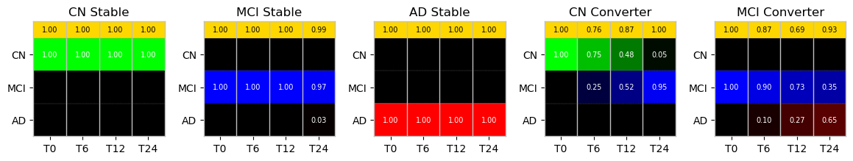
Figure 9: Representative outputs of the ADPG Classifier reshaped into structured grid formats
The ensemble output vector, $Y_{ensemble}$ is mapped to the grid as:
- Row 1 of the grid is constant and mapped to golden color.
- Row 2 of the green channel is assigned ${\tilde{Y}}_{0}, {\tilde{Y}}_{3}, {\tilde{Y}}_{6}, and {\tilde{Y}}_{9}$ for columns 1 through 4.
- Row 3 of the blue channel is assigned ${\tilde{Y}}_{1}, {\tilde{Y}}_{4}, {\tilde{Y}}_{7}, and {\tilde{Y}}_{10}$ for columns 1 through 4.
- Row 4 of the red channel is assigned ${\tilde{Y}}_{2}, {\tilde{Y}}_{5}, {\tilde{Y}}_{8}, and {\tilde{Y}}_{11}$ for columns 1 through 4.
- The remaining rows and columns for each of the channels are set to zero.
The color intensity of each grid tile directly reflects the probability value, with the predicted probability value overlaid to strengthen visual feedback and quantitative interpretation.
The first row of the grid shown in Figure 9 represents the confidence score $C=\{C_{0}, C_{1}, C_{2}, C_{3}\}$ for each temporal group derived from the exponential transformation of uncertainty values. An exponential factor of the maximum uncertainty for the group computes the confidence score for the group.
$$C_{i}= e^{-13.86 . max({\tilde{g}}_{i})}$$
The confidence score range is 0 to 1, with 1 indicating high confidence and a reliable prediction. The exponential factor was set empirically at 13.86 to achieve a variance of 0.05, corresponding to an approximately 0.5 confidence score, and a variance of 0.1, corresponding to a confidence score closer to 0.25.
Results
The proposed framework was evaluated using a test dataset of 568 cases, which represented a diverse range of disease progression trajectories. The test cohort consisted of 139 stable CN, 145 stable MCI, 228 stable AD, seven convertible CN (CNc), 48 convertible MCI (MCIc), and one convertible AD (ADc).
The model yielded an average Grouped Categorical Cross-Entropy (GCCE) loss of 0.1527 ± 0.0056 for the test set. We chose accuracy as an evaluation metric and computed it by first determining the predicted class with the highest probability and comparing it against the ground truth labels to establish binary correctness for each temporal group. The accuracy of each subject was then calculated by averaging the per-group accuracy across time points. Given the inherent class imbalance between the stable (n = 512) and convertible (n = 56) subgroups, performance metrics were analyzed separately for each subset to provide an accurate and efficient assessment of the model.
To evaluate the model’s performance and facilitate a direct comparison of the test cases, the actual and predicted diagnoses generated by the ADPG Classifier are presented side by side. Each visualization contains key identifiers: ID refers to the subject’s index within the dataset, RID denotes the unique ADNI participant identifier, and VISCODE specifies the clinical visit code corresponding to RID for the baseline input T0. In addition, we included an accompanying table containing relevant features with longitudinal data, which serves as a correspondence for readers to track disease progression and reflect it with the model’s prediction. The selected features include MMSE, CDRSB, ADAS13, FAQ, and RAVLT Immediate from the COG modality, APOE4 from the RF modality, FDG and AV45 from the PET modality, normalized hippocampal volume and normalized ventricular volume from the MRI modality, and ABETA from the CSF modality.
Performance on Stable Subjects
For stable cases, the model demonstrated high predictive accuracy of 0.9702, with low epistemic uncertainty of 0.004, corresponding to a standard deviation of 0.0633 in the predictions within the ensembled models. Notably, 80.86% of the stable test cases yielded a minimum confidence score of 0.9 at any temporal prediction point, indicating high model confidence and reliability in the prediction.
Three distinct scenarios emerged when evaluating an output on stable cases:
- high probability predictions for correct diagnosis stage with high confidence scores,
- high probability predictions with a drop in confidence scores, and
- correct predictions with decreased probability (threshold ≥ 0.5) across all temporal groups but consistently low confidence scores.
- Figures 10a-c illustrate the first scenario, where the model successfully generalizes and predicts the ground-truth diagnosis with high probability and confidence over a two-year window.
- Figures 10d illustrate the second scenario, where the prediction probability exceeds 0.8; however, there was a reduction in confidence score compared to the previous scenario. Subject ID 856 was consistently predicted as a stable MCI. Yet, the confidence score ranged from 0.73 to 0.77, indicating moderate variance among individual model outputs.
- Figure 10e-f as the third scenario, as shown through subject ID 4507, the model-maintained classification correctness across all time points using a probabilistic threshold of 0.5, albeit with low confidence scores. Subject ID 3792, a stable AD case, was predicted as MCI progressing towards AD with low confidence at T0 but gradually improved over the prediction horizon as the probability for AD increased.

10a
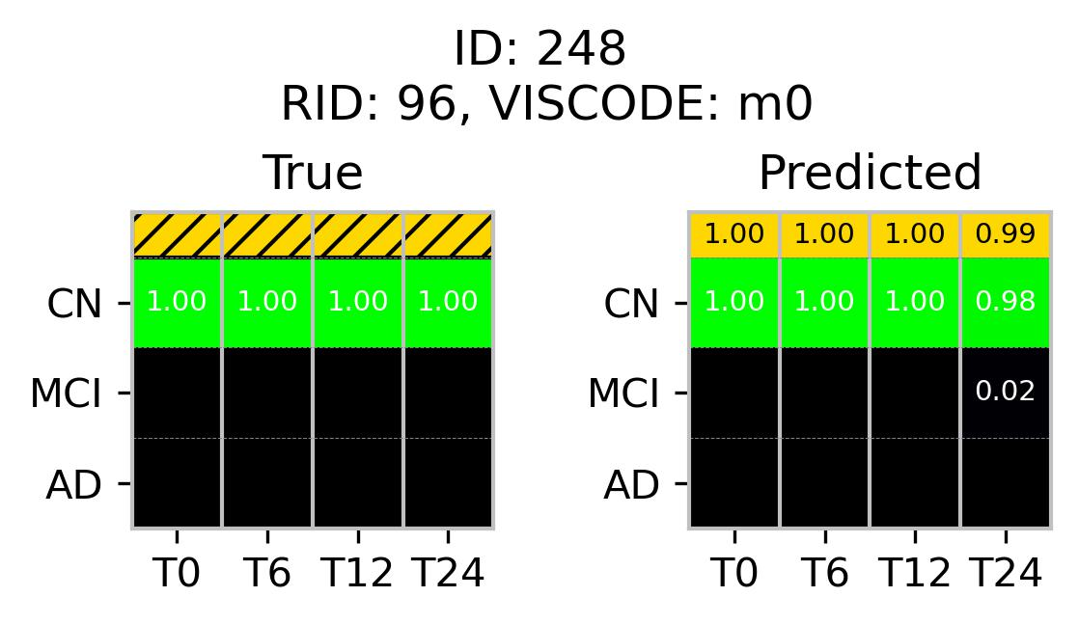
Timepoint | MMSE | CDRSB | ADAS13 | FAQ | RAVLT  Immediate | APOE4 | FDG | AV45 | ABETA | Normalized  Hippocampus | Normalized  Ventricles
T0 | 30 | 0 | 4 | 0 | 51 | 0 | 1.32101 | - | 915.3 | 0.004119 | 0.041108
T6 | 29 | 0 | 3.67 | 0 | 48 | 0 | 1.12015 | - | - | 0.003925 | 0.04112
T12 | 30 | 0 | 3.33 | 0 | 50 | 0 | 1.16527 | - | 682 | 0.003917 | 0.042471
T24 | 28 | 0 | 2.33 | 0 | 56 | 0 | 1.09613 | - | - | 0.003897 | 0.044573

10b
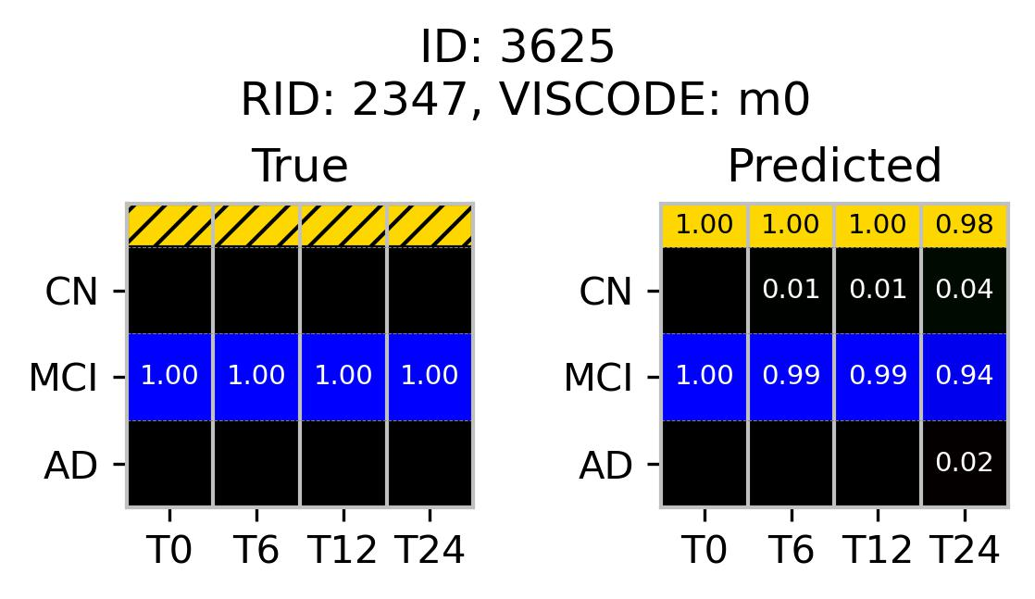
Timepoint | MMSE | CDRSB | ADAS13 | FAQ | RAVLT  Immediate | APOE4 | FDG | AV45 | ABETA | Normalized  Hippocampus | Normalized  Ventricles
T0 | 30 | 1.5 | 11 | 8 | 48 | 1 | 1.3221 | 1.0429 | 1010 | - | 0.02839
T6 | 30 | 1.5 | 9 | 6 | 45 | 1 | - | - | - | 0.004719 | 0.02899
T12 | 30 | 1.5 | 10 | 2 | 40 | 1 | - | - | - | 0.004726 | 0.0296
T24 | 30 | 2 | 8 | 8 | 43 | 1 | 1.421 | 0.9599 | 1081 | - | 0.02939

10c
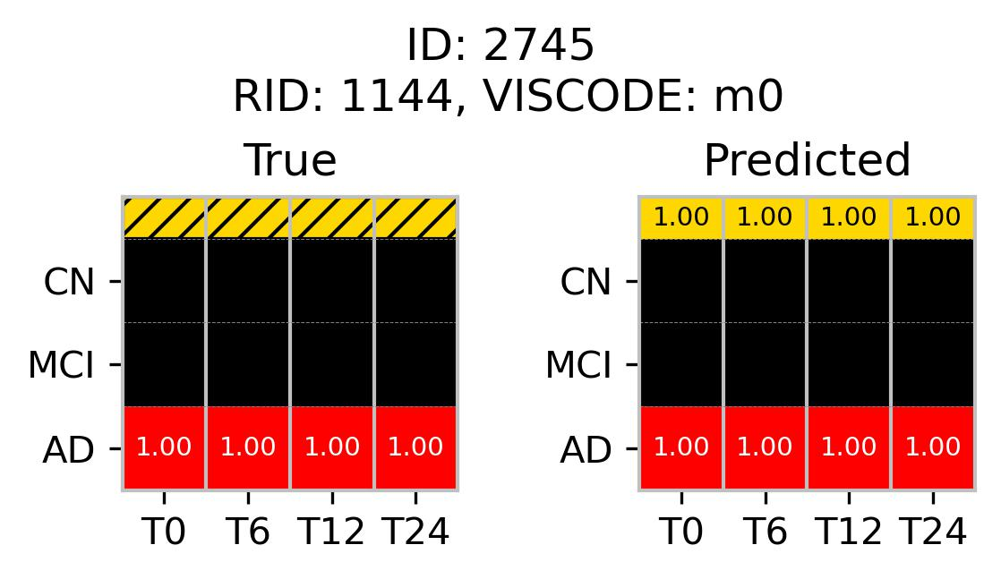
Timepoint | MMSE | CDRSB | ADAS13 | FAQ | RAVLT  Immediate | APOE4 | FDG | AV45 | ABETA | Normalized  Hippocampus | Normalized  Ventricles
T0 | 21 | 3.5 | 27.67 | 13 | 18 | 1 | 1.1791 | - | 564.2 | 0.003208 | 0.030235
T6 | 25 | 1 | 32.33 | 0 | 16 | 1 | 1.1171 | - | - | 0.003198 | 0.031912
T12 | 26 | 1.5 | 31 | 1 | 19 | 1 | 1.1369 | - | 678.3 | 0.003061 | 0.032393
T24 | 25 | 1.5 | 35.67 | 6 | 18 | 1 | 1.0498 | - | - | 0.002961 | 0.035536

10d
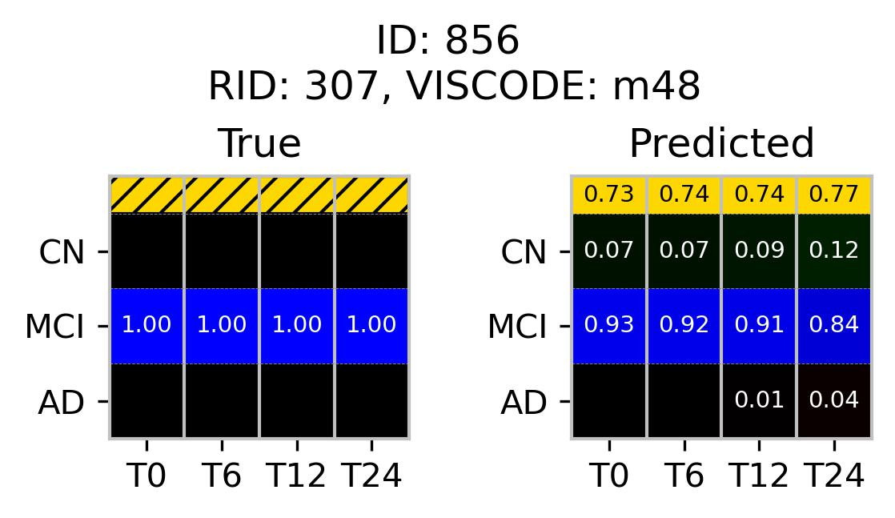
Timepoint | MMSE | CDRSB | ADAS13 | FAQ | RAVLT  Immediate | APOE4 | FDG | AV45 | ABETA | Normalized  Hippocampus | Normalized  Ventricles
T0 | 29 | 1.5 | 16.67 | 0 | 24 | 0 | - | - | 1013 | 0.004534 | 0.022872
T6 | - | - | - | - | - | 0 | - | - | - | - | -
T12 | 30 | 2 | 18 | 4 | 25 | 0 | 1.2178 | 1.1463 | 940.3 | 0.004776 | 0.025127
T24 | 29 | 3.5 | 20 | 7 | 30 | 0 | - | - | - | 0.004749 | 0.028646

10e
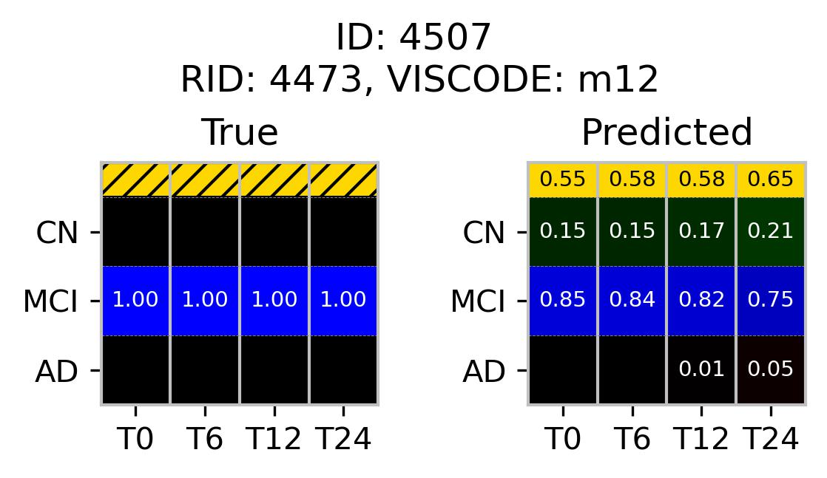
Timepoint | MMSE | CDRSB | ADAS13 | FAQ | RAVLT  Immediate | APOE4 | FDG | AV45 | ABETA | Normalized  Hippocampus | Normalized  Ventricles
T0 | 29 | 0.5 | 9 | 0 | 46 | 1 | - | - | - | - | 0.043686
T6 | - | - | - | - | - | 1 | - | - | - | - | -
T12 | 29 | 0.5 | 9 | 2 | 47 | 1 | 1.2876 | 1.5014 | 818.8 | 0.004582 | -
T24 | 30 | 1 | 7 | 3 | 43 | 1 | - | - | - | 0.004464 | -

10f
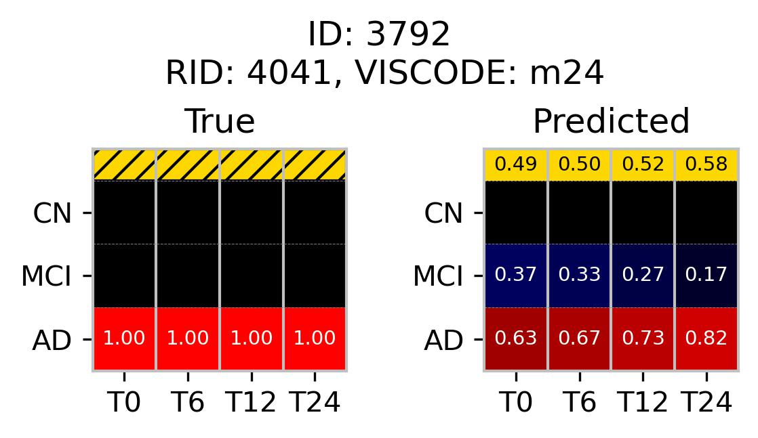
Timepoint | MMSE | CDRSB | ADAS13 | FAQ | RAVLT  Immediate | APOE4 | FDG | AV45 | ABETA | Normalized  Hippocampus | Normalized  Ventricles
T0 | 26 | 5 | 19 | 21 | 45 | 0 | 1.281 | 0.9185 | >1700 | 0.004148 | 0.01987
T6 | - | - | - | - | - | 0 | - | - | - | - | -
T12 | 27 | 5 | 23 | 21 | 42 | 0 | - | - | - | - | -
T24 | 27 | 5 | 22 | 19 | 39 | 0 | - | 0.9191 | - | - | -

Performance on Convertible Subjects
In contrast, convertible cases presented greater classification challenges, with the model achieving an overall accuracy of 0.7277 and an elevated epistemic uncertainty of 0.0166, resulting in an average standard deviation of 0.129 in probability prediction within the ensembled models. Only 19.64% of these cases achieved a minimum confidence score higher than 0.9 at the given temporal point, whereas 67.86% achieved a confidence score of 0.7 or higher. This outcome suggests a noticeable reduction in model certainty when predicting progression in convertible cases. The model’s highest probabilistic prediction at each time group did not always exhibit a one-to-one correspondence with the actual diagnostic stages; however, the model successfully identified transitional patterns within the two-year prediction window for most cases. The model performed optimally, with consistent predictive capabilities for the MCI-to-AD transition; however, it underperformed for the CN-to-MCI and MCI-to-CN transitions.
Three primary scenarios emerged in convertible cases:
- Figure 11a-c illustrates the model’s ability to detect convertible cases with high confidence scores when the transitions occurred at different time points. The subjects had converted from MCI to AD at different temporal stages, but the dominant probability at T24 was AD in all cases.
- Figures 11d-e display the predicted instances where the model successfully captured the overall transitioning pattern, albeit at the cost of a low confidence score at T0. However, the confidence score improved along with the probability for the next disease stage as the temporal sequence progressed.
- Figures 11f-h represent more challenging cases where the model captured transitional characteristics less effectively. The directional trend of disease progression was captured for these subjects, but the progressive stage probabilities did not exceed the 0.5 threshold during the two-year window required for correct classification.
11a
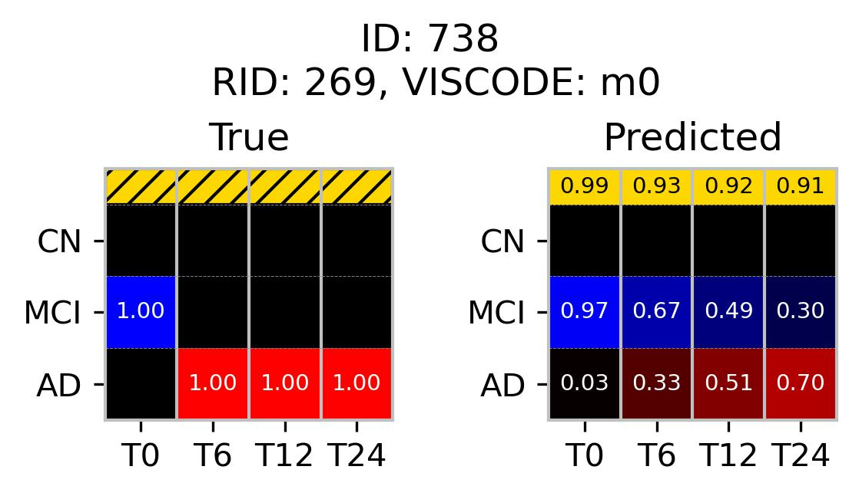
Timepoint | MMSE | CDRSB | ADAS13 | FAQ | RAVLT  Immediate | APOE4 | FDG | AV45 | ABETA | Normalized  Hippocampus | Normalized  Ventricles
T0 | 28 | 2.5 | 20.67 | 18 | 28 | 1 | - | - | 576.8 | 0.00374 | 0.028189
T6 | 24 | 6 | 16.33 | 20 | 29 | 1 | - | - | - | - | 0.030089
T12 | 23 | 5.5 | 27.67 | 20 | 34 | 1 | - | - | 500.1 | - | 0.031289
T24 | 22 | 6 | 29.67 | 25 | 31 | 1 | - | - | - | 0.003388 | 0.035363

11b
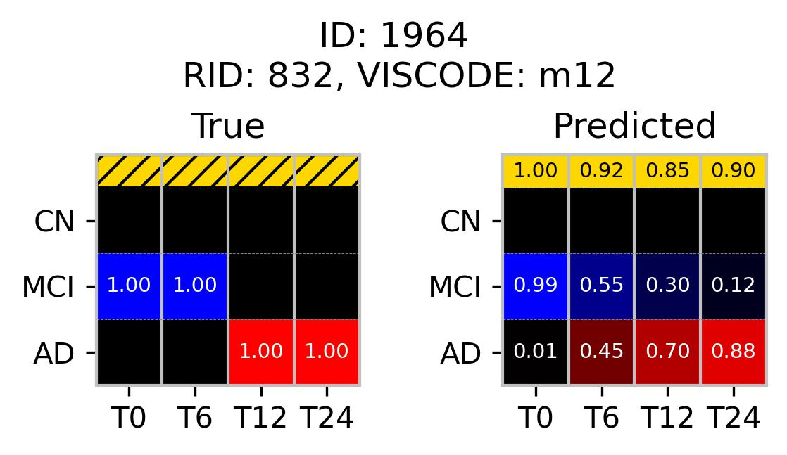
Timepoint | MMSE | CDRSB | ADAS13 | FAQ | RAVLT  Immediate | APOE4 | FDG | AV45 | ABETA | Normalized  Hippocampus | Normalized  Ventricles
T0 | 26 | 4 | 28.67 | 11 | 9 | 1 | - | - | - | 0.003961 | 0.049739
T6 | 27 | 4 | 34.33 | 11 | 19 | 1 |  |  |  | 0.003961 | 0.0051827
T12 | 23 | 5 | - | - | - | 1 | - | - | - | 0.003815 | 0.053924
T24 | - | - | - | - | - | - | - | - | - | - | -

11c
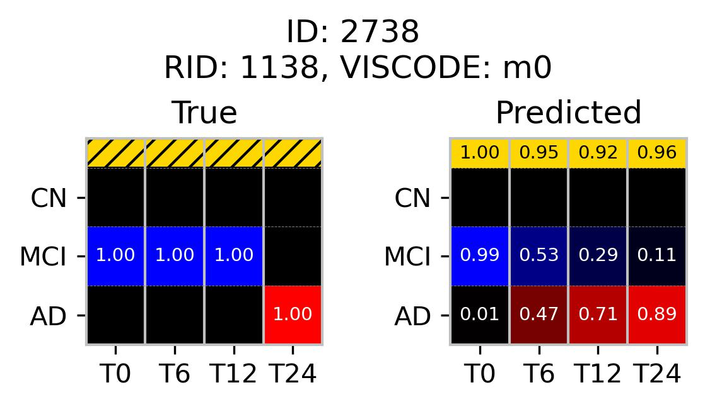
Timepoint | MMSE | CDRSB | ADAS13 | FAQ | RAVLT  Immediate | APOE4 | FDG | AV45 | ABETA | Normalized  Hippocampus | Normalized  Ventricles
T0 | 27 | 3.5 | 30 | 10 | 29 | 2 | - | - | - | 0.004113 | 0.021335
T6 | 25 | 3.5 | 20.33 | 16 | 18 | 2 | - | - | - | 0.004338 | 0.022114
T12 | 24 | 5.5 | 27.33 | 24 | 22 | 2 | - | - | - | - | -
T24 | 20 | 10 | 43.67 | 28 | 9 | 2 | - | - | - | - | -

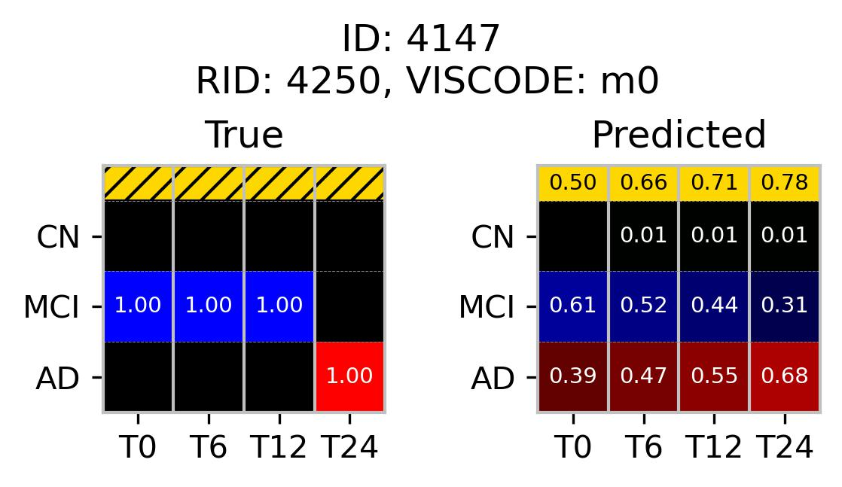
Timepoint | MMSE | CDRSB | ADAS13 | FAQ | RAVLT  Immediate | APOE4 | FDG | AV45 | ABETA | Normalized  Hippocampus | Normalized  Ventricles
T0 | 29 | 2.5 | 20 | 10 | 32 | 1 | 1.1001 | 1.31279 | 757.1 | 0.004178 | 0.027849
T6 | 26 | 1.5 | 26 | 11 | 29 | 1 | - | - | - | 0.003967 | 0.028871
T12 | 28 | 2.5 | 25 | 14 | 24 | 1 | - | - | - | 0.003855 | 0.030247
T24 | 21 | 6 | 31 | 22 | 18 | 1 | 0.99168 | 1.22021 | 584.6 | 0.003589 | 0.03451

11d

11e
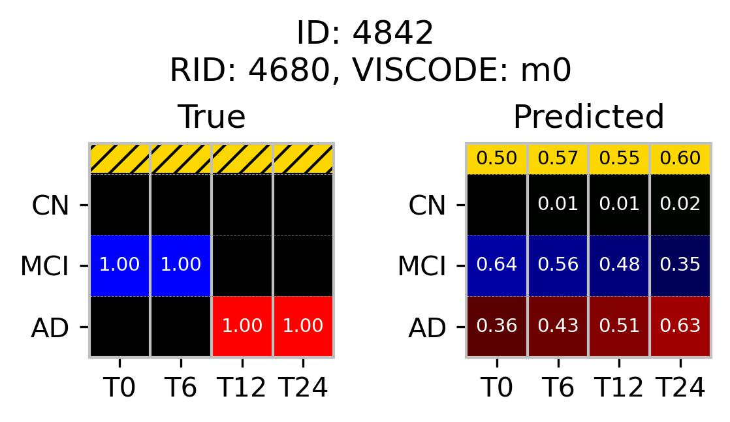
Timepoint | MMSE | CDRSB | ADAS13 | FAQ | RAVLT  Immediate | APOE4 | FDG | AV45 | ABETA | Normalized  Hippocampus | Normalized  Ventricles
T0 | 29 | 1.5 | 17 | 12 | 36 | 2 | 1.1663 | 1.36814 | 487.9 | 0.00503 | 0.0136
T6 | 26 | 3.5 | 17 | 12 | 35 | 2 | - | - | - | 0.00498 | 0.014647
T12 | 27 | 5.5 | 22 | 19 | 25 | 2 | - | - | - | 0.00482 | 0.015576
T24 | 27 | 7 | 29 | 30 | 18 | 2 | 0.9742 | 1.42578 | - | 0.0045 | 0.019122

11f
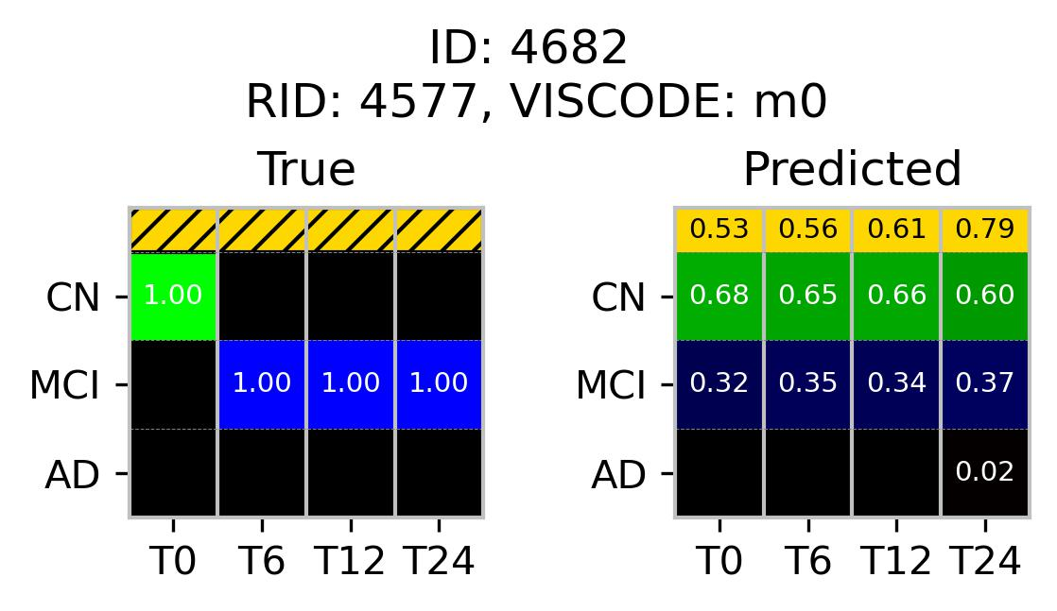
Timepoint | MMSE | CDRSB | ADAS13 | FAQ | RAVLT  Immediate | APOE4 | FDG | AV45 | ABETA | Normalized  Hippocampus | Normalized  Ventricles
T0 | 29 | 0 | 16 | 0 | 38 | 2 | 1.36357 | 1.17132 | 318.3 | - | 0.020607
T6 | 26 | 0.5 | 21 | 0 | 24 | 2 | - | - | - | - | -
T12 | 29 | 0.5 | 20 | 0 | 29 | 2 | - | - | - | - | 0.020754
T24 | 28 | 0.5 | 14 | 0 | 22 | 2 | - | - | - | - | -

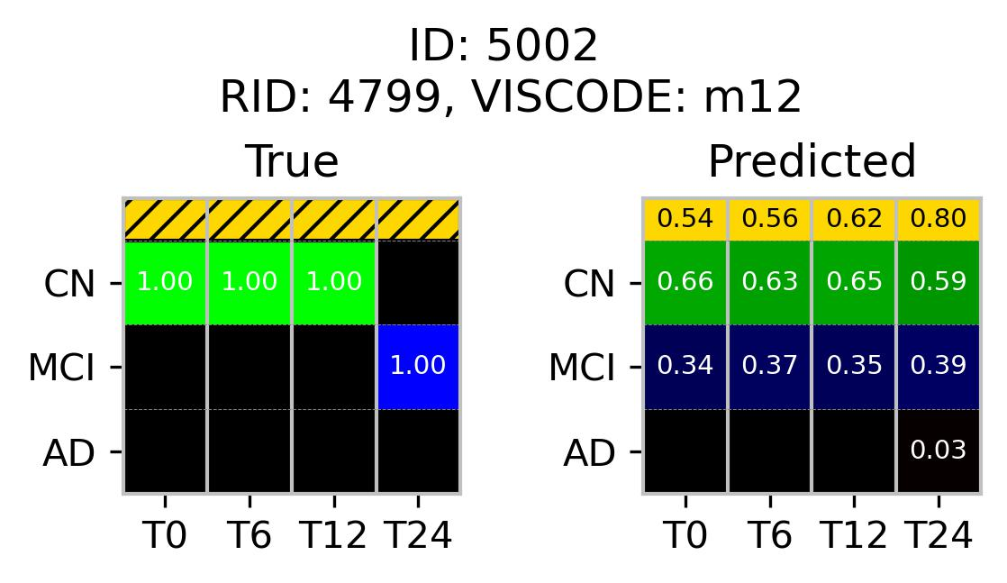
Timepoint | MMSE | CDRSB | ADAS13 | FAQ | RAVLT  Immediate | APOE4 | FDG | AV45 | ABETA | Normalized  Hippocampus | Normalized  Ventricles
T0 | 30 | 0 | 9 | 1 | 41 | 0 | - | - | - | 0.00487 | 0.021363
T6 | - | - | - | - | - | 0 | - | - | - | - | -
T12 | 30 | 0 | 7 | 0 | 47 | 0 | - | 1.36208 | 716.7 | 0.00484 | 0.022728
T24 | 30 | 2 | 11 | 0 | 38 | 0 | - | - | - | - | -

11g

11h
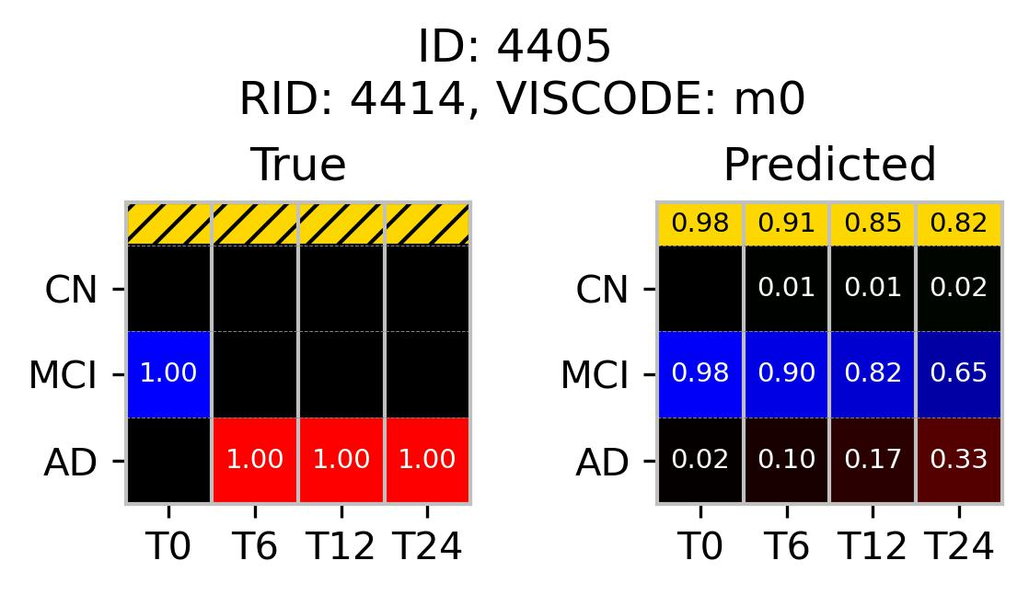
Timepoint | MMSE | CDRSB | ADAS13 | FAQ | RAVLT  Immediate | APOE4 | FDG | AV45 | ABETA | Normalized  Hippocampus | Normalized  Ventricles
T0 | 28 | 2.5 | 20 | 3 | 47 | 1 | 1.25123 | 1.24057 | 969.7 | 0.004869 | 0.012287
T6 | 25 | 3.5 | 17 | 13 | 35 | 1 | - | - | - | 0.004798 | 0.014568
T12 | 26 | - | 24 | 6 | 30 | 1 | - | - | - | 0.00461 | 0.014821
T24 | 25 | 4.5 | 29 | 13 | 32 | 1 | 1.1628 | 1.35981 | 811.5 | 0.004046 | 0.019288

Detection of Preclinical Transition
The classifier also exhibited potential for early detection of future transitions not captured within the 2-year test period. In some test subjects, the model predicted an increasing probability of diagnostic transition, despite the ground-truth labels maintaining a stable diagnostic status over the two years. Upon extending the follow-up data, the subjects had subsequently transitioned into a progressive stage at a later period. This type of transition suggests that the model was able to capture early conversion indicators of future decline. For instance:
- Figure 12(a), subject ID 1074 was diagnosed as stable MCI for an observed period of 2 years but had eventually converted to AD at T36 (three years from baseline). The model initially predicted MCI but showed an increasing probability of AD over 2 years from baseline, validating its early detection capability.
- Figure 12(b) for subject ID 1873 presents a stable CN for the first 2 years from baseline but transitions to MCI at T48 (four years from baseline). The model predicted CN predominantly, with a low but rising probability for MCI, underscoring the model’s potential to capture the transitioning patterns that will emerge from baseline indicators over time.
12a
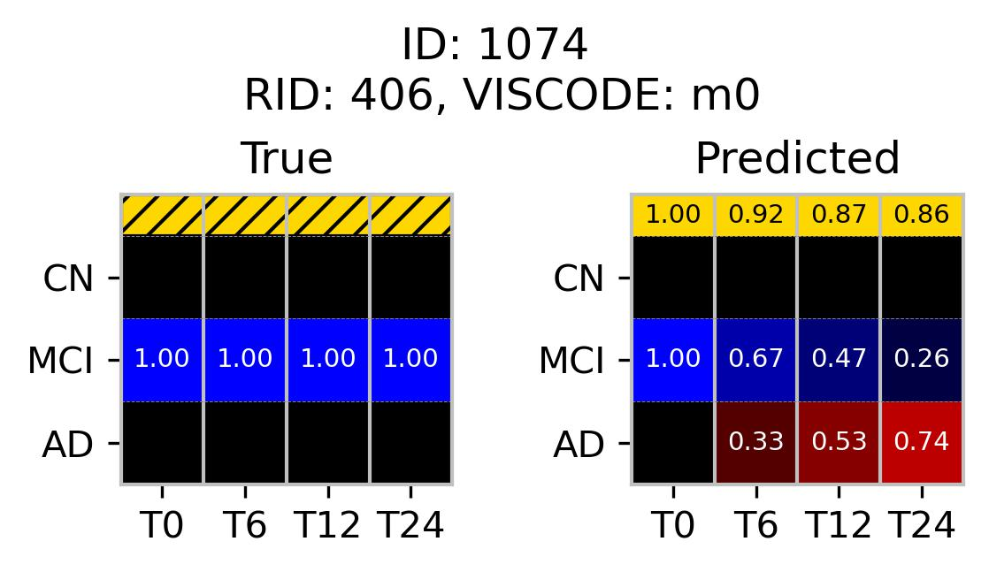
Timepoint | MMSE | CDRSB | ADAS13 | FAQ | RAVLT  Immediate | APOE4 | FDG | AV45 | ABETA | Normalized  Hippocampus | Normalized  Ventricles
T0 | 29 | 2.5 | 27.33 | 14 | 27 | 1 | - | - | - | 0.003317 | 0.048974
T6 | 28 | 1 | 19.33 | 1 | 23 | 1 | - | - | - | 0.003292 | 0.051283
T12 | 26 | 3 | - | 4 | 23 | 1 | - | - | - | 0.003367 | 0.050735
T24 | 26 | 2.5 | 29.33 | 9 | 18 | 1 | - | - | - | 0.003135 | 0.056532
T36 | 20 | 6 | 37.67 | 14 | 22 | 1 | - | - | - | - | 0.059646

12b
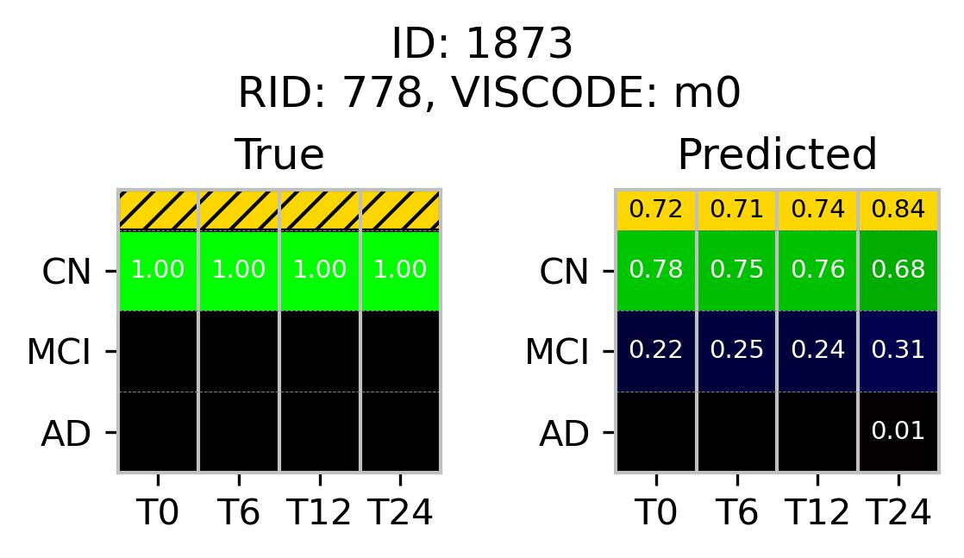
Timepoint | MMSE | CDRSB | ADAS13 | FAQ | RAVLT  Immediate | APOE4 | FDG | AV45 | ABETA | Normalized  Hippocampus | Normalized  Ventricles
T0 | 28 | 0 | 9.33 | 0 | 34 | 1 | 1.6271 | - | 668.2 | - | 0.018151
T6 | 27 | 0 | 15.67 | 0 | 35 | 1 | 1.5736 | - | - | 0.004447 | 0.017968
T12 | 28 | 0 | 15.67 | 0 | 33 | 1 | 1.5977 | - | 557.3 | 0.004491 | 0.017915
T24 | 26 | 1.5 | 15 | 1 | 36 | 1 | 1.5051 | - | - | 0.004363 | 0.018442
T36 | 27 | 1.5 | 13.33 | 3 | 34 | 1 | 1.4711 | - | 718.9 | 0.004287 | 0.019373
T48 | 26 | 3 | 19 | 7 | 37 | 1 | 1.4629 | 1.26 | 567.5 | 0.004881 | 0.023266

Limitations and Misclassifications
Despite the strong performance in these previous cases, the model had a limitation in predicting and generalizing certain atypical or ambiguous trajectories.
- Figure 13(a), subject ID 1716 exhibited stable MCI for 5 years from baseline; however, the model indicated a false positive for conversation, predicting a gradual increase in AD probability from T6 to T24.
- Figure 13(b) exhibits a non-monolithic trajectory for subject 307, where the diagnostic states alternate between CN and MCI (CN at T6 and T24, MCI at T0 and T12). In contrast, the model predicted a stable MCI with a high confidence score yet failed to capture the diagnostic fluctuations.
- Figures 13c-e illustrate distinct cases where the model misclassified the diagnostic trajectory. Subject ID 4283 is a stable CN case, which was misclassified as stable MCI. Conversely, subject ID 4102 was diagnosed as having stable MCI, which the model predicted as inconclusive, with mixed probabilities for both MCI and CN, but skewed towards CN. Subject 1127 depicts a reversible AD transitioning to MCI at T6 and remaining MCI thereafter; however, the model predicted the opposite phenomenon: MCI converter transitioning to AD.
13a
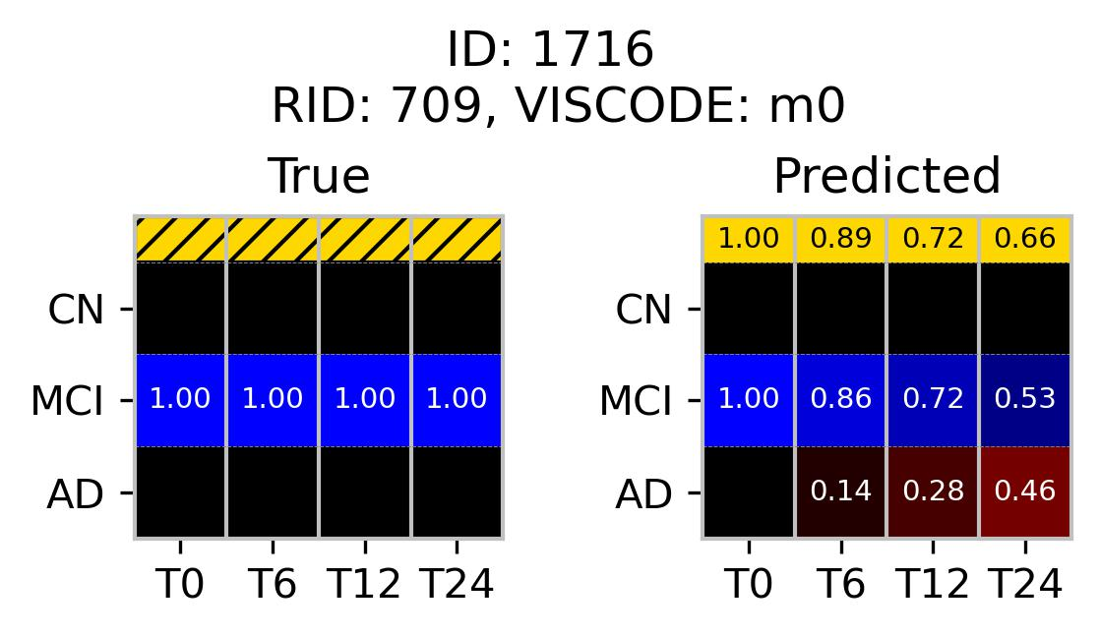
Timepoint | MMSE | CDRSB | ADAS13 | FAQ | RAVLT  Immediate | APOE4 | FDG | AV45 | ABETA | Normalized  Hippocampus | Normalized  Ventricles
T0 | 30 | 1.5 | 15.33 | 9 | 28 | 1 | 1.10833 | - | - | 0.004461 | 0.033508
T6 | 28 | 1.5 | 19.67 | 9 | 23 | 1 | 1.10811 | - | - | 0.004489 | 0.035704
T12 | 30 | 2 | 13.33 | 10 | 30 | 1 | 1.09547 | - | - | 0.004567 | 0.035618
T24 | 30 | 2.5 | 18 | 10 | 31 | 1 | - | - | - | 0.004643 | 0.036212
T36 | 28 | 3 | 20.33 | 10 | 29 | 1 | 1.14521 | - | - | 0.004359 | 0.037379
T48 | 29 | 2.5 | 19 | 10 | 29 | 1 | - | - | - | 0.004422 | 0.0388
T60 | 26 | 2 | 20 | 13 | 29 | 1 | 1.07907 | 1.6168 | - | 0.004289 | 0.043569

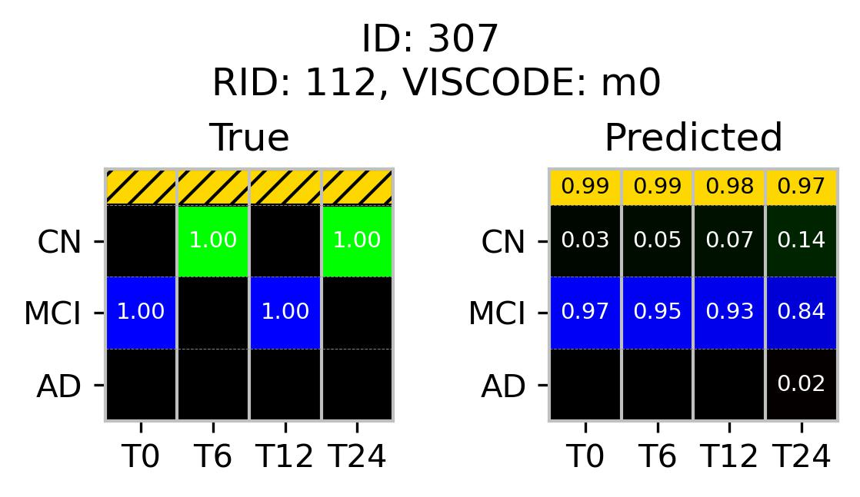
Timepoint | MMSE | CDRSB | ADAS13 | FAQ | RAVLT  Immediate | APOE4 | FDG | AV45 | ABETA | Normalized  Hippocampus | Normalized  Ventricles
T0 | 30 | 1.5 | 9 | 0 | 50 | 1 | 1.19883 | - | 498.6 | 0.004844 | 0.02457
T6 | 29 | 0.5 | 8 | 0 | 43 | 1 | 1.19093 | - | - | 0.004908 | 0.025996
T12 | 28 | 0.5 | 7.67 | 1 | 60 | 1 | 1.15418 | - | 464.4 | 0.00472 | 0.02779
T24 | 29 | 0.5 | 3.67 | 0 | 63 | 1 | 1.13847 | - | 394.8 | 0.004656 | 0.029027
T36 | 29 | 0.5 | 5.33 | 0 | - | 1 | 1.24369 | - | 369 | 0.004724 | 0.030722
T48 | 30 | 1.5 | 5.33 | 2 | 48 | 1 | - | - | 418.9 | 0.004503 | 0.032137

13b

13c
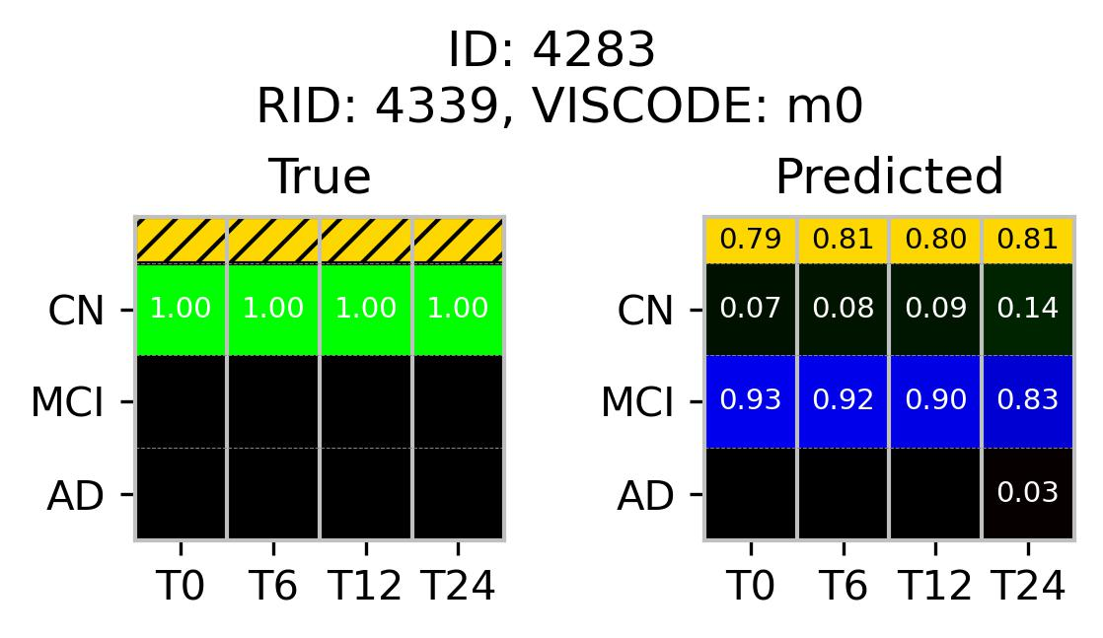
Timepoint | MMSE | CDRSB | ADAS13 | FAQ | RAVLT  Immediate | APOE4 | FDG | AV45 | ABETA | Normalized  Hippocampus | Normalized  Ventricles
T0 | 29 | 1 | 15 | 0 | 26 | 2 | 1.36665 | 1.40683 | 481.2 | 0.004771 | 0.026748
T6 | 29 | 0 | 12 | 0 | 31 | 2 | - | - | - | 0.004652 | 0.027326
T12 | 24 | 0 | 10 | 0 | 34 | 2 | - | - | - | 0.004699 | 0.027825
T24 | 29 | 0 | 8 | 0 | 26 | 2 | 1.52203 | 1.45962 | - | 0.004571 | 0.027938

13d
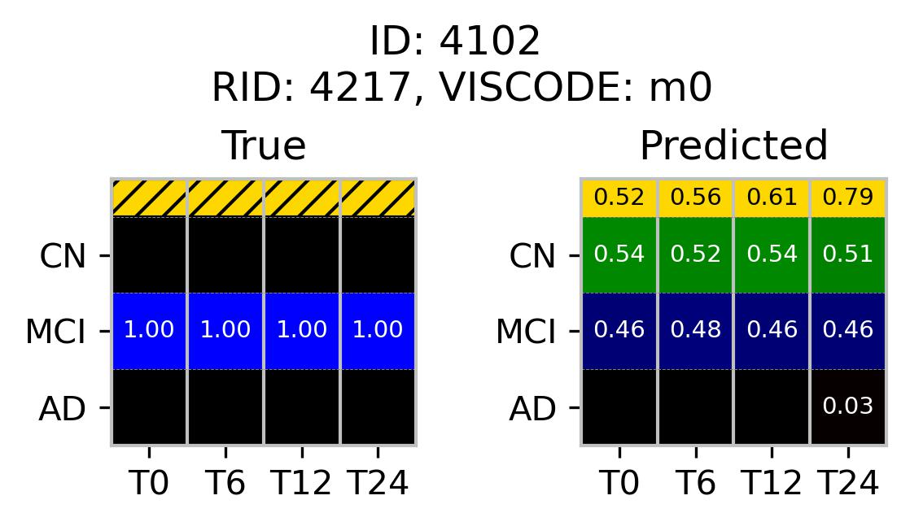
Timepoint | MMSE | CDRSB | ADAS13 | FAQ | RAVLT  Immediate | APOE4 | FDG | AV45 | ABETA | Normalized  Hippocampus | Normalized  Ventricles
T0 | 30 | 0.5 | 6 | 0 | 40 | 0 | 1.2694 | 0.90388 | 1684 | 0.004783 | 0.025635
T6 | 28 | 0.5 | 18 | 3 | 24 | 0 | - | - | - | 0.004703 | 0.025998
T12 | 29 | 1.5 | 7 | 2 | 31 | 0 | - | - | - | 0.0047 | 0.026407
T24 | 28 | 1.5 | 9 | 4 | 32 | 0 | 1.2486 | - | - | 0.004675 | 0.027511

13e
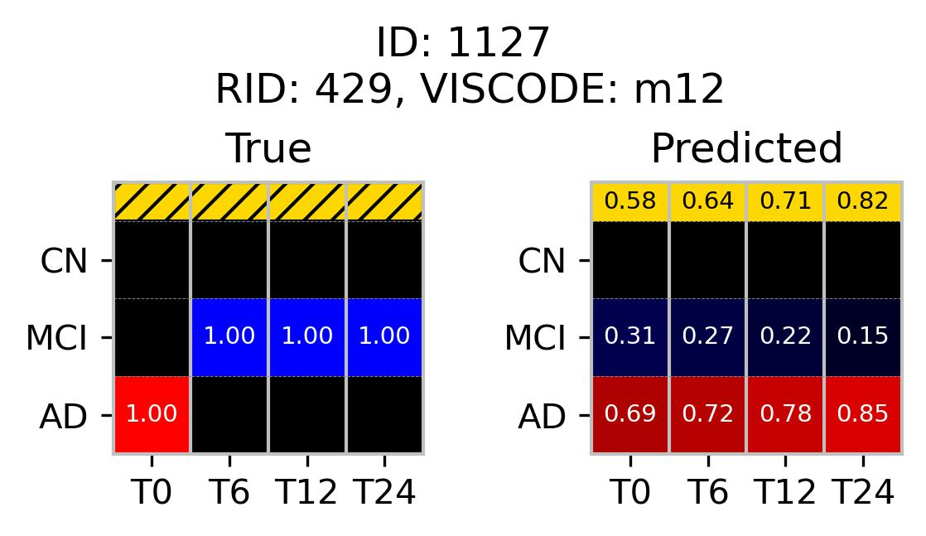
Timepoint | MMSE | CDRSB | ADAS13 | FAQ | RAVLT  Immediate | APOE4 | FDG | AV45 | ABETA | Normalized  Hippocampus | Normalized  Ventricles
T0 | 25 | 1 | 22.33 | 6 | 18 | 0 | - | - | 1139 | 0.00475 | 0.015638
T6 | 26 | 0.5 | 26 | 1 | 20 | 0 | - | - | - | 0.004654 | 0.015969
T12 | 25 | 1.5 | 25.67 | 4 | 20 | 0 | - | - | - | 0.004806 | 0.016828
T24 | 26 | 1.5 | 26.67 | 4 | 15 | 0 | - | - | - | 0.004499 | 0.017836

Comparative Evaluation with ML4VISAD

To contextualize our findings with a previous methodological framework, we conducted a direct comparison with the ML4VISAD model from our earlier work [Eslami et al., 2023; Adjouadi et al., 2024] to evaluate the prediction accuracy differences. Figure 14 includes the predicted grid generated by our ADPG Classifier, a 23 × 23 color-coded ML4VISAD image representing disease progression, and associated SUVR scores.
- Figure 14a-b show two MCI subjects who transitioned to AD at T24. The ML4VISAD model correctly identified the transition in Figure 14a but misclassified the subject in Figure 14b as stable MCI. In contrast, our model was consistent in detecting transitioning patterns with increasing probability for AD and assigned AD probabilities of 53% and 59% respectively, at T24.
- Figure 14c shows a CN subject who transitioned to MCI at T24. The ML4VISAD output had predominantly green pixels associated with CN, along with scattered blue patches for MCI, and lacked a coherent indicator for the conversion pattern. On the other hand, our model predicted the subject with a higher CN probability but also detected gradually emerging MCI traits, reflected in the MCI probability increasing from 21% at T0 to 30% at T24.
- Figure 14d demonstrates a case of stable MCI for a two-year period that converted to AD at T36 (three years post-baseline). While both models captured the conversion patterns early on, the ML4VISAD model predicted the transition to AD occurring at T24. In contrast, our grid classifier output displayed a progressively increasing AD probability from 9% at T0 to 72% at T24, accompanied by an improving confidence score across temporal groups.
- Figure 14e presents a reversible case where the subject transitioned back to CN from the MCI stage. The ML4VISAD model incorrectly predicted it as stable CN throughout the sequence. On the contrary, our model reflected the reversal trend to some extent by showing a declining MCI probability and ultimately ending with 36% for CN and 60% for MCI at T24.
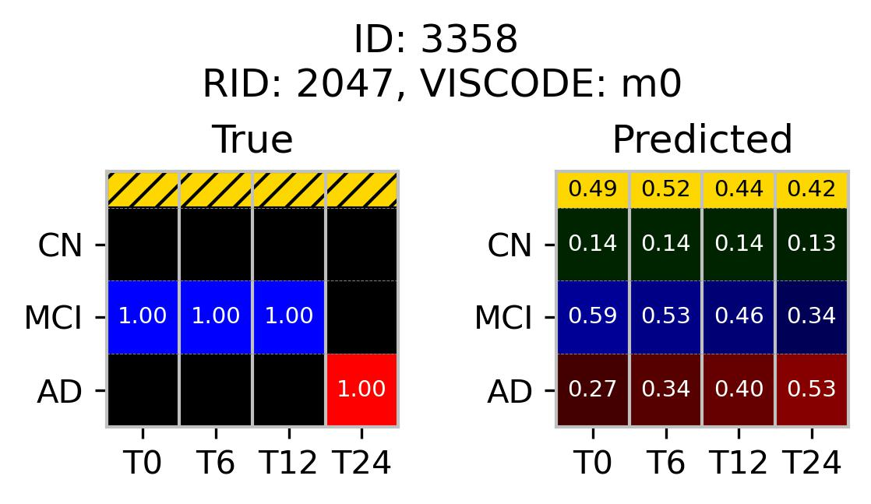

Timepoint | MMSE | CDRSB | ADAS13 | FAQ | RAVLT  Immediate | APOE4 | FDG | AV45 | ABETA | Normalized  Hippocampus | Normalized  Ventricles
T0 | 27 | 2.5 | 14 | 22 | 26 | 1 | 1.4361 | 1.6971 | 709.2 | 0.004385 | 0.014359
T6 | 27 | 4.5 | 13 | 12 | 33 | 1 | - | - | - | 0.004297 | 0.01469
T12 | 26 | 6 | 17 | 10 | 33 | 1 | - | - | - | 0.00414 | 0.014569
T24 | 28 | 5.5 | 20 | 15 | 25 | 1 | 1.449 | 1.673 | 723.9 | 0.00412 | 0.014988

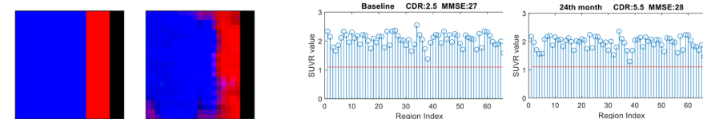
14a

Referenced from Fig. 3k
(Eslami et al., 2023)

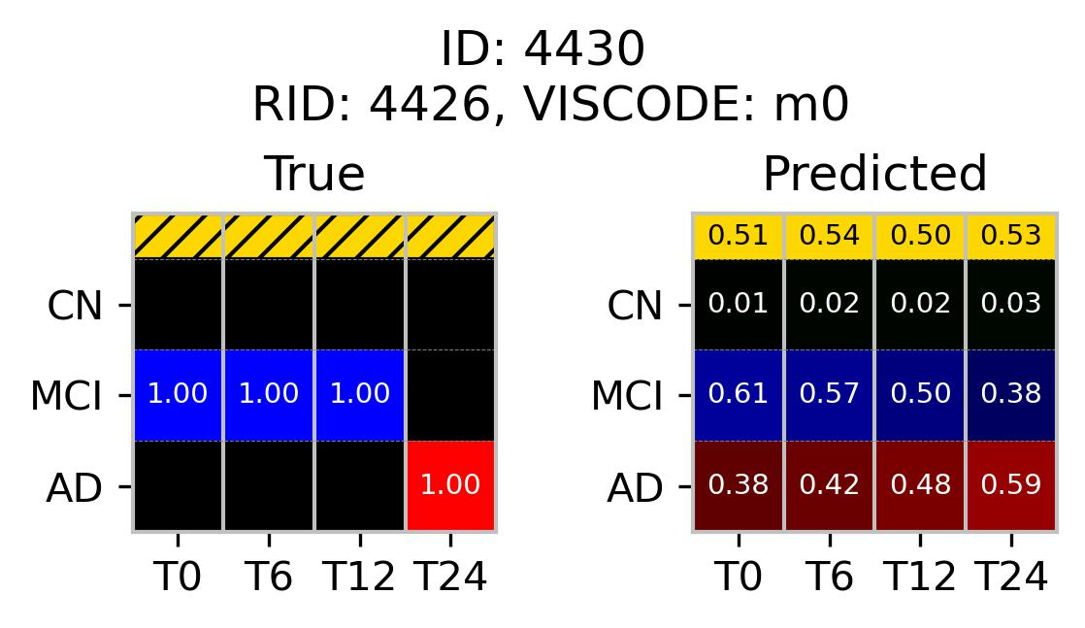

Timepoint | MMSE | CDRSB | ADAS13 | FAQ | RAVLT  Immediate | APOE4 | FDG | AV45 | ABETA | Normalized  Hippocampus | Normalized  Ventricles
T0 | 28 | 5.5 | 24 | 4 | 29 | 0 | 1.3668 | 0.92036 | 819.6 | 0.00319 | 0.055722
T6 | 27 | 2 | 18 | 5 | 20 | 0 | - | - | - | - | 0.057259
T12 | 29 | 2.5 | 16 | 6 | 29 | 0 | - | - | - | 0.003113 | 0.056479
T24 | 26 | 2.5 | 22 | 3 | 22 | 0 | 1.3053 | 0.89138 | 840.4 | - | -

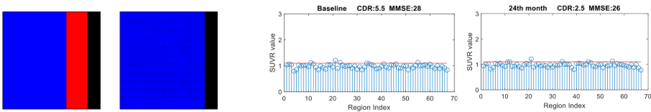
14b

Referenced from Fig. 3l
(Eslami et al., 2023)

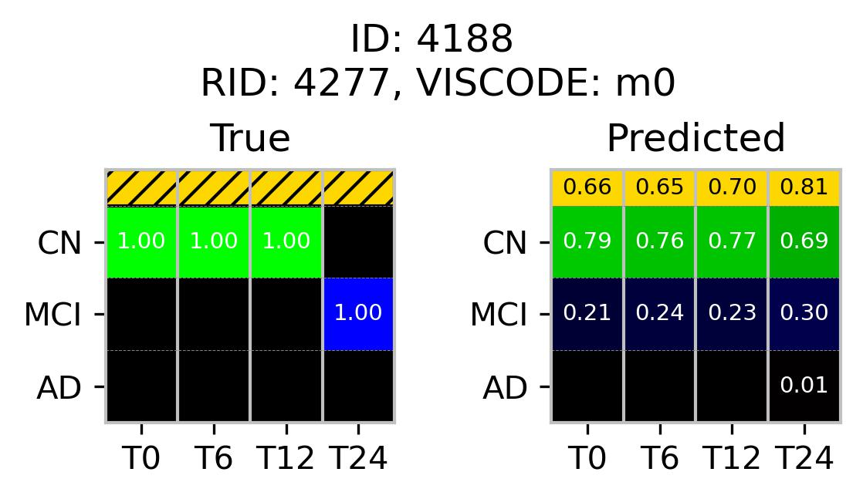

Timepoint | MMSE | CDRSB | ADAS13 | FAQ | RAVLT  Immediate | APOE4 | FDG | AV45 | ABETA | Normalized  Hippocampus | Normalized  Ventricles
T0 | 28 | 0 | 8 | 0 | 52 | 0 | 1.4879 | 1.3756 | >1700 | 0.004604 | 0.010878
T6 | 30 | 0 | 3 | 0 | 48 | 0 | - | - | - | 0.004768 | -
T12 | 28 | 0 | 6 | 0 | 51 | 0 | - | - | - | 0.004579 | 0.012127
T24 | 30 | 0 | 5 | 0 | 63 | 0 | - | - | - | 0.0044 | 0.012128

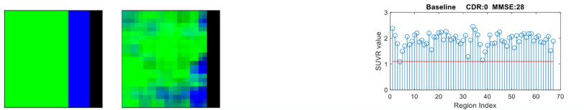
14c

Referenced from Fig. 3i
(Eslami et al., 2023)

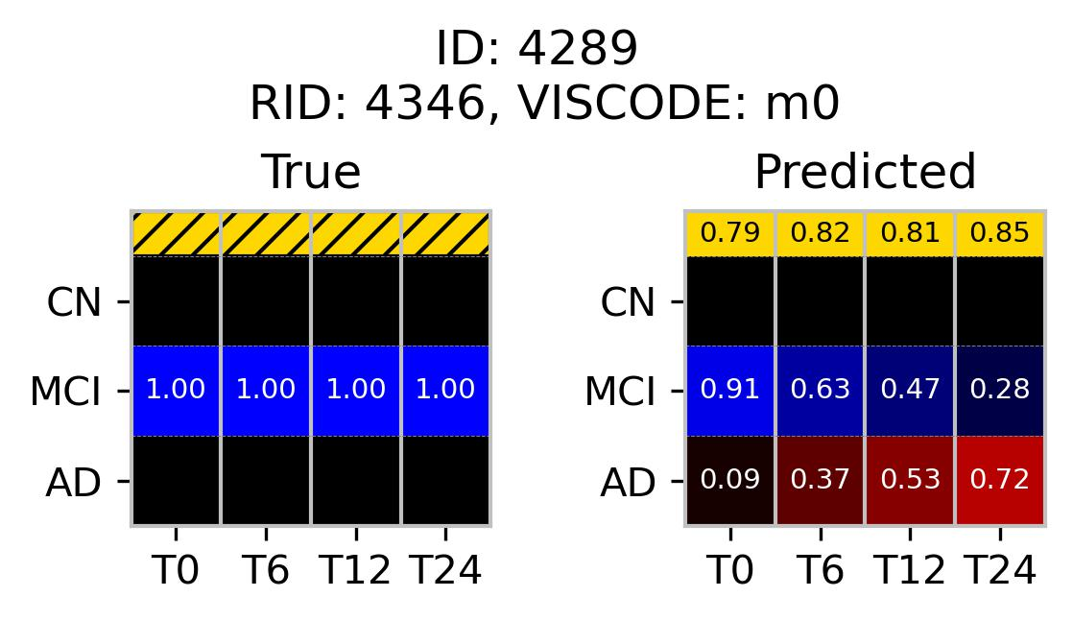

Timepoint | MMSE | CDRSB | ADAS13 | FAQ | RAVLT  Immediate | APOE4 | FDG | AV45 | ABETA | Normalized  Hippocampus | Normalized  Ventricles
T0 | 29 | 1.5 | 19 | 15 | 44 | 2 | 1.23038 | 1.2601 | 664.5 | 0.00333 | 0.030605
T6 | 30 | 2.5 | 20 | 18 | 39 | 2 | - | - | - | 0.003252 | 0.031312
T12 | 29 | 3 | 24 | 15 | 33 | 2 | - | - | - | - | 0.031577
T24 | 27 | 2.5 | 24 | 16 | 37 | 2 | 1.23147 | 1.2078 | 624.8 | - | -
T36 | 28 | 5 | 23 | 25 | 37 | 2 | - | - | - | - | -
T48 | 26 | 4.5 | 29 | 22 | 34 | 2 | - | 1.2492 | 588.6 | - | -

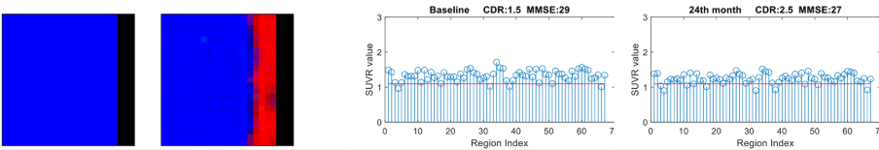
14d

Referenced from Fig. 3h
(Eslami et al., 2023)

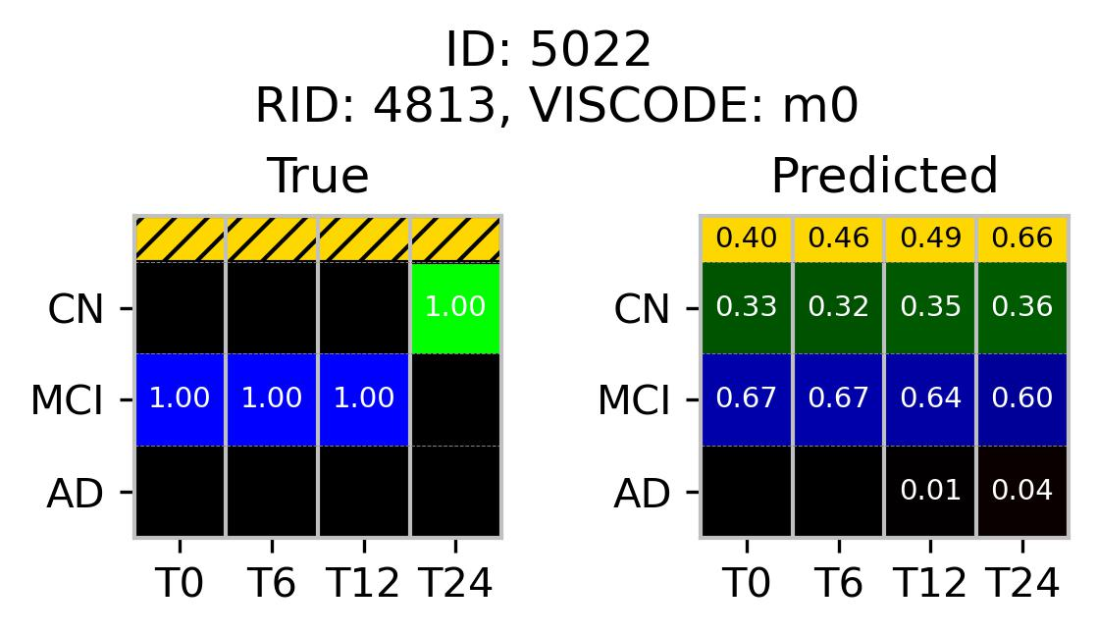

Timepoint | MMSE | CDRSB | ADAS13 | FAQ | RAVLT  Immediate | APOE4 | FDG | AV45 | ABETA | Normalized  Hippocampus | Normalized  Ventricles
T0 | 29 | 1 | 8 | 0 | 61 | 0 | 1.2773 | 1.22143 | >1700 | 0.005826 | 0.009137
T6 | 29 | 1 | 4 | 1 | 56 | 0 | - | - | - | 0.005825 | 0.009791
T12 | 27 | 1 | 14 | 1 | 45 | 0 | - | - | - | 0.005676 | 0.009621
T24 | 27 | 1 | 6 | 0 | 45 | 0 | - | 1.1981 | >1700 | 0.005734 | 0.010015

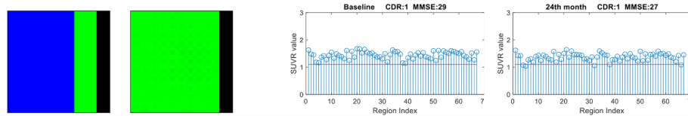
14e

Referenced from Fig. 3j
(Eslami et al., 2023)

Discussion:
The proposed ADPG Classifier framework offers a structured and interpretable solution for predicting Alzheimer’s disease progression across multiple longitudinal time points. By modeling stage-specific probabilities and integrating a confidence metric, the system facilitates informed clinical decision-making—especially valuable in differentiating stable from convertible diagnostic cases. Analysis across the three diagnostic stages (CN, MCI, and AD) revealed substantial overlap in individual features, highlighting the multifactorial nature of AD staging. Consequently, clinicians often rely on multiple data modalities—including cognitive scores, SUVR values, and fluid biomarkers, though the relative importance of each feature can vary between practitioners. This subjectivity introduces variability in diagnostic outcomes. In this context, the ADPG Classifier acts as a standardized decision-support tool that reduces potential bias by quantifying uncertainty and offering probabilistic predictions with confidence scores. Furthermore, by providing a forward-looking trajectory of disease progression, the model enables clinicians to schedule follow-ups more proactively and tailor interventions strategically to patient-specific risk timelines.
- Performance Analysis: Stable versus Transitioning Cases
The model demonstrated high classification accuracy and confidence for subjects with stable diagnostic trajectories. Some misclassifications were observed among subjects undergoing early-stage transitions, as depicted in Figures 13(a), 13(b), and 14(d). These errors partly reflect the nuanced, non-linear nature of Alzheimer’s disease progression. In contrast to stable cases, prediction performance declined in transitioning cases, largely due to the complex and individualized patterns of change across disease stages. AD progression is not always linear; transient reversals and variable progression rates are common, complicating prediction tasks.
Despite this complexity, the ADPG Classifier successfully captured meaningful transition patterns in most convertible cases. For many individuals, the model assigned elevated probabilities to the progressive diagnostic class well before an actual transition occurred, with these probabilities increasing steadily across future time points. Notably, cases shown in Figure 12 exemplify the model’s ability to anticipate transitions even beyond the two-year prediction window, indicating that it effectively encodes long-range temporal dependencies from baseline data alone.
However, the reliance on baseline (T0) data limits the model’s precision in estimating the exact timing of a transition. Moreover, the model exhibited reduced accuracy in handling subjects with fluctuating diagnoses or those progressing through multiple stages within the two-year span—particularly evident in Figure 13(b). These limitations highlight the need for future enhancements that incorporate interim time points or adaptive retraining based on updated patient data to better capture dynamic disease trajectories
- Comparison to ML4VISAD
Our approach introduces a significant architectural simplification over the ML4VISAD framework while enhancing interpretability and predictive performance. ML4VISAD employed a computationally demanding design that utilized fully connected layers for feature extraction, followed by transposed 2D convolutions to generate pixel-based visualizations. This process, though novel, required substantial computational resources during training and introduced complexity in interpreting the resulting outputs. In contrast, our streamlined architecture replaces the transposed convolutional layers with a deep stack of fully connected layers. These layers first expand the baseline multimodal features and then compress them into a low-dimensional probabilistic representation across diagnostic states and time points. This probability vector is subsequently mapped into a 4×4 grid by a dedicated grid classifier to generate visually interpretable disease progression trajectories.
This architectural refinement not only reduced computational overhead but also improved prediction accuracy and yielded clinically meaningful visualizations of disease evolution, as demonstrated in Figure 14. While ML4VISAD marked uncertain regions with opaque black bars at the right edge of its output images, it lacked explicit quantification or interpretability of those uncertainties. To address this shortcoming, we introduced a robust uncertainty quantification strategy by leveraging an ensemble of 25 models. The variability in their predictions was used to compute epistemic uncertainty, which we transformed into confidence scores for each time point. These scores provide clinicians with a clearer understanding of the model’s reliability, offering actionable insights for patient-specific monitoring and decision-making.
- Study Limitations
Several factors limited the performance and generalizability of the proposed framework. The primary design choice to rely solely on baseline data for predicting two-year progression trajectories, while simplifying data requirements and clinical workflow, inherently restricted the model’s ability to detect intermediate changes between visits. This limitation reduced prediction precision for later time points, particularly at 24 months (T24). Notably, the misclassification rate was higher at T24, especially for transitions occurring within this period, indicating that baseline features alone may not contain sufficient prognostic information to accurately forecast longer-term progression.
Another key constraint was the dataset’s imbalanced composition: stable cases outnumbered transitioning cases by approximately 7:1. Within the transitioning subset, the majority represented conversions from MCI to AD. This imbalance likely contributed to the model’s superior predictive accuracy for stable cases and MCI-to-AD converters relative to other transition types, highlighting a potential bias towards the most prevalent progression patterns.
Additionally, missing data points across multimodal features necessitated imputation, which may have introduced noise and uncertainty in model training and evaluation. Prediction confidence also declined when the model output showed a more even probability distribution between two diagnostic classes at a given time point. This phenomenon was attributed to increased variance in predictions across the ensemble models, reflecting inherent uncertainty in borderline or ambiguous cases.
Future work should explore incorporating longitudinal data beyond baseline and applying methods to address class imbalance and the missing data challenge more effectively, thereby enhancing prediction accuracy and clinical utility across diverse disease trajectories.
- Future Work
To overcome current limitations, future work will prioritize more rigorous dataset curation with the aims to improve class balance, reduce the prevalence of missing data, and increase the inclusion of subjects who convert between diagnostic categories at varying timepoints. These enhancements are expected to strengthen the model’s generalizability and mitigate the prediction variability observed across ensemble members.
On the architectural front, we plan to advance the current framework by integrating Graph Convolutional Networks (GCNs) combined with Transformer-based attention mechanisms. This hybrid design will enable the model to simultaneously capture spatial relationships among multimodal features and temporal dependencies across longitudinal data. Unlike traditional architectures, this approach has the potential to natively accommodate incomplete data without requiring explicit imputation, directly addressing existing data quality challenges. Moreover, the attention mechanism within the Transformer is anticipated to improve model robustness by dynamically prioritizing features based on their contextual relevance to disease progression, thereby reducing variance in output predictions and enhancing interpretability.
Conclusion
Alzheimer’s disease affects millions of individuals globally, with pathological changes occurring years before the onset of overt clinical symptoms. One of the persistent challenges lies in accurately estimating the rate and direction of disease progression, necessitating periodic assessments to monitor disease progression. Therefore, we aimed to address this gap and developed a new framework backed by a machine learning model to estimate the probabilistic trajectory of Alzheimer’s disease over two years using only baseline data. Its backbone, the AlzProgNet architecture incorporates grouped categorical cross-entropy (GCCE) loss and a robust ensemble of independently trained networks, yielding improved resistance to ambiguous or atypical diagnosis labels and variability in disease trajectories. The machine learning model encodes baseline data to long-range temporal patterns to generate probability distributions at baseline, six months, twelve months, and twenty-four months. The probabilistic outputs are further integrated into a grid-based classifier to generate an interpretable visualization platform.
The classifier not only achieved high accuracy for stable cases but also showed strong performance in identifying cases of clinical conversion, often predicting transitions months in advance of expert-confirmed diagnoses. Its novel 4×4 visual grid framework supports quantifiable and more meaningful decision-making by integrating prediction probabilities with uncertainty quantification, a critical advancement for clinical translation. Furthermore, the ADPG Classifier demonstrated improvements over the prior ML4VISAD model in terms of computational efficiency, interpretability, and reliability under class imbalance and missing data conditions.
While challenges remain—including the need to address intermediate progression states and optimize for rare conversion paths—this work lays a foundation for scalable, personalized care planning in Alzheimer's disease. Future development will explore graph-based temporal models and attention mechanisms to enhance longitudinal pattern recognition and further mitigate data sparsity. Ultimately, the ADPG Classifier offers a promising pathway toward real-time clinical decision support, aiding early intervention strategies and reducing diagnostic ambiguity in complex neurodegenerative trajectories. Additionally, confidence scores for each prediction period in the visualizer present practitioners with access to the reliability of the model’s forecasts.
Acknowledgements:
This research is supported by the National Science Foundation (NSF) under grants CNS1920182, and CNS-2018611, and NIH grants: NIA/NIH 5R01AG061106-02, NIA/NIH 5R01AG047649-05, and the NIA/NIH 1P30AG066506-01 with the 1Florida ADRC.

References
- Adjouadi, M., Eslami, M., & Tabarestani, S. (2024). Systems and methods for color-coded visualization to aid in diagnosis and prognosis of Alzheimer's (U.S. Patent No. 11,989,932). U.S. Patent and Trademark Office.
- Alzheimer’s Disease Neuroimaging Initiative (ADNI). (2024). ADNIMERGE dataset (Version: 2024_Q1) [Data set]. http://adni.loni.usc.edu/
- Alzheimer’s Association. (2024). 2024 Alzheimer’s disease facts and figures [PDF]. Alzheimer's & Dementia, 20(5). Retrieved from https://www.alz.org/getmedia/76e51bb6-c003-4d84-8019-e0779d8c4e8d/alzheimers-facts-and-figures.pdf
- Anoop, A., Singh, P. K., Jacob, R. S., & Maji, S. K. (2010). CSF biomarkers for Alzheimer's disease diagnosis. International Journal of Alzheimer’s Disease, 2010, Article 606802
- Bateman, R. J., Xiong, C., Benzinger, T. L., Fagan, A. M., Goate, A., Fox, N. C., ... & Morris, J. C. (2012). Clinical and biomarker changes in dominantly inherited Alzheimer’s disease. New England Journal of Medicine, 367(9), 795–804. https://doi.org/10.1056/NEJMoa1202753
- Baumeister, H., Vogel, J. W., Insel, P. S., Kleineidam, L., Wolfsgruber, S., Stark, M., Gellersen, H. M., Yakupov, R., Schmid, M. C., et al. (2024). A generalizable data-driven model of atrophy heterogeneity and progression in memory clinic settings. Brain, 147(7), 2400–2413. https://doi.org/10.1093/brain/awae118
- Binette, A. P., Smith, R., Hansson, O., et al. (2025). Evaluation of the revised criteria for biological and clinical staging of Alzheimer disease. JAMA Neurology, 82(7), 666–675.
- Braak, H., & Braak, E. (1991). Neuropathological stageing of Alzheimer-related changes. Acta Neuropathologica, 82(4), 239–259. https://doi.org/10.1007/BF00308809
- Cho, S. H., Woo, S., Kim, C., Kim, H. J., Jang, H., Kim, B. C., Kim, S. E., Kim, S. J., Kim, J. P., Jung, Y. H., Lockhart, S., Ossenkoppele, R., Landau, S., Na, D. L., Weiner, M., Kim, S., & Seo, S. W. (2021). Disease progression modelling from preclinical Alzheimer’s disease (AD) to AD dementia. Scientific Reports, 11(1), Article 4168. https://doi.org/10.1038/s41598-021-83585-3
- El-Sappagh, S., Ali, F., Abuhmed, T., Singh, J., & Alonso, J. M. (2022). Automatic detection of Alzheimer’s disease progression: An efficient information fusion approach with heterogeneous ensemble classifiers. Neurocomputing, 512, 203–224.
- Eslami, M., Tabarestani, S., & Adjouadi, M. (2023). A unique color-coded visualization system with multimodal information fusion and deep learning in a longitudinal study of Alzheimer's disease. Artificial Intelligence in Medicine, 135, 102473.
- Hansson, O. (2021). Biomarkers for neurodegenerative diseases. Nature Medicine, 27(6), 954–963. https://doi.org/10.1038/s41591-021-01388-2
- Hardy, J., & Selkoe, D. J. (2002). The amyloid hypothesis of Alzheimer’s disease: Progress and problems on the road to therapeutics. Science, 297(5580), 353–356. https://doi.org/10.1126/science.1072994
- Hemmy, L. S., Linskens, E. J., Silverman, P. C., Miller, M. A., Talley, K. M. C., Taylor, B. C., Ouellette, J. M., Greer, N. L., Wilt, T. J., Butler, M., & Fink, H. A. (2020). Brief cognitive tests for distinguishing clinical Alzheimer-type dementia from mild cognitive impairment or normal cognition in older adults with suspected cognitive impairment: A systematic review. Annals of Internal Medicine, 172(10), 678–685.
- Jack, C. R., Jr., Bennett, D. A., Blennow, K., Carrillo, M. C., Dunn, B., Haeberlein, S. B., ... & Silverberg, N. (2018). NIA-AA Research Framework: Toward a biological definition of Alzheimer’s disease. Alzheimer’s & Dementia, 14(4), 535–562. https://doi.org/10.1016/j.jalz.2018.02.018
- Janelidze, S., Berron, D., Smith, R., Strandberg, O., Palmqvist, S., van Westen, D., ... & Hansson, O. (2021). Associations of plasma phospho-tau217 levels with tau positron emission tomography in early Alzheimer disease. JAMA Neurology, 78(2), 149–156. https://doi.org/10.1001/jamaneurol.2020.4201
- Janelidze, S., Mattsson, N., Palmqvist, S., Smith, R., Beach, T. G., Serrano, G. E., ... & Hansson, O. (2020). Plasma P-tau181 in Alzheimer's disease: Relationship to other biomarkers, differential diagnosis, neuropathology and longitudinal progression to Alzheimer's dementia. Nature Medicine, 26(3), 379–386. https://doi.org/10.1038/s41591-020-0755-1
- Janelidze, S., Stomrud, E., Smith, R., Strandberg, O., Palmqvist, S., Mattsson, N., & Hansson, O. (2023). Plasma biomarkers of Alzheimer’s disease pathology and clinical progression. Nature Medicine, 29(3), 544–555. https://doi.org/10.1038/s41591-023-02275-1
- Khosravi, M., Parsaei, H., Rezaee, K., & Helfroush, M. S. (2024). Fusing convolutional learning and attention-based Bi-LSTM networks for early Alzheimer’s diagnosis from EEG signals towards IoMT. Scientific Reports, 14(1). https://doi.org/10.1038/s41598-024-77876-8
- Landau, S. M., Harvey, D., Madison, C. M., Reiman, E. M., Foster, N. L., Aisen, P. S., ... & Jack, C. R., Jr. (2010). Associations between cognitive, functional, and FDG-PET measures of decline in AD and MCI. Neurology, 75(3), 230–238. https://doi.org/10.1212/WNL.0b013e3181e8e8b8
- Lee, J., Heo, D., Choi, K.-H., & Kim, H.-J. (2024). Impact of the ventricle size on Alzheimer’s disease progression: A retrospective longitudinal study. Dementia and Neurocognitive Disorders, 23(2), 95–106.
- Long, J. M., Coble, D. W., Xiong, C., Schindler, S. E., Perrin, R. J., Gordon, B. A., Benzinger, T. L. S., Grant, E., Fagan, A. M., Harari, O., & others. (2022). Preclinical Alzheimer’s disease biomarkers accurately predict cognitive and neuropathological outcomes. Brain, 145(12), 4506–4518.
- Lu, J., Chen, M., Yang, Y., Xie, Y., & Wang, S. (2022). Deep learning for Alzheimer's disease progression prediction: A systematic review. Frontiers in Aging Neuroscience, 14, 837303. https://doi.org/10.3389/fnagi.2022.837303.
- Lu, X., Zhang, Y., Tang, Y., Bernick, C., & Shan, G. (2024). Conversion to Alzheimer's disease dementia from normal cognition directly or with the intermediate mild cognitive impairment stage. Alzheimer’s & Dementia, 21(1), e14393. https://doi.org/10.1002/alz.14393
- Malepathirana, T., Senanayake, D., Gautam, V., Engel, M., Balez, R., Lovelace, M. D., Sundaram, G., Heng, B. J. M., Chow, S., Marquis, C., & others. (2023). Visualization of incrementally learned projection trajectories for longitudinal data. Scientific Reports, 13, 5521. https://doi.org/10.1038/s41598-023-32359-3
- Marcus, C., Mena, E., & Subramaniam, R. M. (2014). Brain PET in the diagnosis of Alzheimer’s disease. AJR. American Journal of Roentgenology, 202(1), W321–W331.
- Mielke, M. M. (2018). Sex and gender differences in Alzheimer’s disease dementia. Psychiatric Times, 35(11), 14–17. https://www.ncbi.nlm.nih.gov/pmc/articles/PMC6390276/
- Nguyen, M., Li, D., & Nguyen, T. (2023). Challenges and opportunities of machine learning in Alzheimer's disease diagnosis and prognosis. Journal of Biomedical Informatics, 135, 104231. https://doi.org/10.1016/j.jbi.2023.104231
- Olaimat, M. A., Bozdag, S., Saeed, F., & Alzheimer’s Disease Neuroimaging Initiative (2025). TA‐RNN: an Attention‐based Time‐aware Recurrent Neural Network Architecture to Predict Progression of Alzheimer’s Disease. Alzheimer's & Dementia, 20(Suppl 1), e089010. https://doi.org/10.1002/alz.089010
- Ortiz, A., Munilla, J., Gorriz, J. M., & Ramírez, J. (2016). Ensembles of deep learning architectures for the early diagnosis of Alzheimer's disease. International Journal of Neural Systems, 26(7), 1650025. https://doi.org/10.1142/S0129065716500257
- Palmqvist, S., Janelidze, S., Quiroz, Y. T., Zetterberg, H., & Blennow, K. (2023). Blood biomarkers for Alzheimer’s disease — current state and future directions. Nature Reviews Neurology, 19(4), 225–243. https://doi.org/10.1038/s41582-023-00750-x
- Pan, Y., Liu, M., Lian, C., & Shen, D. (2020). Synthesizing missing PET from MRI and label via convolutional 3D GAN for Alzheimer’s disease diagnosis. Medical Image Analysis, 64, 101708. https://doi.org/10.1016/j.media.2020.101708
- Rajan, K. B., Weuve, J., Barnes, L. L., McAninch, E. A., Wilson, R. S., & Evans, D. A. (2021). Population estimate of people with clinical AD and mild cognitive impairment in the United States (2020–2060). Alzheimer's & Dementia, 17(12), 1966–1975. https://doi.org/10.1002/alz.12362.
- Ramalingam, S., P. Gowsikraja, E. Loganathan, A. Logeswaran, Ramkumar, N., & K. Geetha. (2024). Attention-Based RNN for Alzheimer’s Diagnosis: A Multi-Modal Approach with Enhanced Feature Retention Algorithm. 1–5. https://doi.org/10.1109/incowoco64194.2024.10863383
- Rice, L., & Bisdas, S. (2017). The diagnostic value of FDG and amyloid PET in Alzheimer’s disease: A systematic review. European Journal of Radiology, 94, 16–24.
- Roberts, R. O., Aakre, J. A., Kremers, W. K., Roberts, R., Vassilaki, M., Mielke, M. M., … Petersen, R. C. (2018). Prevalence and outcomes of amyloid positivity among persons without dementia in a longitudinal, population‑based setting. JAMA Neurology, 75(8), 970–979. https://doi.org/10.1001/jamaneurol.2018.0629
- Rokach, L. (2010). Ensemble-based classifiers. Artificial Intelligence Review, 33(1–2), 1–39.
- Rosselli, M., Vélez Uribe, I., Ahne, E., & Shihadeh, L. (2022). Culture, ethnicity, and level of education in Alzheimer’s disease. Neurotherapeutics, 19(1), 26–54.
- Seo, K., Pan, R., Lee, D. J., Thiyyagura, P., Chen, K., & Alzheimer’s Disease Neuroimaging Initiative. (2019). Visualizing Alzheimer's disease progression in low dimensional manifolds. Heliyon, 5(8), e02216. https://doi.org/10.1016/j.heliyon.2019.e02216
- Sperling, R. A., Aisen, P. S., Beckett, L. A., Bennett, D. A., Craft, S., Fagan, A. M., ... & Phelps, C. H. (2011). Toward defining the preclinical stages of Alzheimer’s disease: Recommendations from the National Institute on Aging-Alzheimer’s Association workgroups on diagnostic guidelines for Alzheimer’s disease. Alzheimer’s & Dementia, 7(3), 280–292. https://doi.org/10.1016/j.jalz.2011.03.003
- Thaipisuttikul, P., Jaikla, K., Satthong, S., & Wisajun, P. (2022). Rate of conversion from mild cognitive impairment to dementia in a Thai hospital-based population: A retrospective cohort. Alzheimer's & Dementia: Translational Research & Clinical Interventions, 8(1), e12272.
- Troutwine, B. R., Hamid, L., Lysaker, C. R., Strope, T. A., & Wilkins, H. M. (2022). Apolipoprotein E and Alzheimer's disease. Acta Pharmaceutica Sinica B, 12(2), 496–510. https://doi.org/10.1016/j.apsb.2021.10.002
- Weiner, M. W., Veitch, D. P., Aisen, P. S., Beckett, L. A., Cairns, N. J., Green, R. C., ... & Jagust, W. (2023). Recent publications from the Alzheimer’s Disease Neuroimaging Initiative: Reviewing progress toward improved biomarker discovery and disease understanding. Alzheimer’s & Dementia, 19(1), 38–54. https://doi.org/10.1002/alz.12634
- Weiner, M. W., Veitch, D. P., Aisen, P. S., Beckett, L. A., Cairns, N. J., Green, R. C., Harvey, D., Jack, C. R., Jagust, W., Liu, E., Morris, J. C., Petersen, R. C., Saykin, A. J., Schmidt, M. E., Shen, L., Siuciak, J. A., Soares, H., Toga, A. W., & Trojanowski, J. Q. (2015). 2014 Update of the Alzheimer's Disease Neuroimaging Initiative: A review of papers published since its inception. Alzheimer's & Dementia, 11(6), e1–e120. https://doi.org/10.1016/j.jalz.2014.11.001
- Wen, J., Thibeau-Sutre, E., Diaz-Melo, M., Samper-González, J., Routier, A., Bottani, S., ... & Colliot, O. (2022). Convolutional neural networks for classification of Alzheimer’s disease: Overview and reproducible evaluation. Medical Image Analysis, 63, 101694. https://doi.org/10.1016/j.media.2020.101694
- Whitwell, J. L. (2010). Progression of atrophy in Alzheimer’s disease and related disorders. Neurotoxicity Research, 18(3), 339–346.
- Whitwell, J. L., Przybelski, S. A., Weigand, S. D., Knopman, D. S., Boeve, B. F., Petersen, R. C., & Jack, C. R., Jr. (2007). 3D maps from multiple MRI illustrate changing atrophy patterns as subjects progress from mild cognitive impairment to Alzheimer’s disease. Brain, 130(Pt 7), 1777–1786. https://doi.org/10.1093/brain/awm112
- World Health Organization. (2025, [31 March]). Dementia [Fact sheet]. Retrieved from https://www.who.int/news-room/fact-sheets/detail/dementia
- Ye, B. S., Kim, H. J., Kim, Y. J., Jung, N.-Y., Lee, J. S., Lee, J., Jang, Y. K., Yang, J.-J., Lee, J.-M., Vogel, J. W., Na, D. L., & Seo, S. W. (2018). Longitudinal outcomes of amyloid positive versus negative amnestic mild cognitive impairments: a three‑year longitudinal study. Scientific Reports, 8, Article 5557. https://doi.org/10.1038/s41598-018-23676-w
- Yu, W., Lei, B., Wang, S., Liu, Y., Feng, Z., Hu, Y., Shen, Y., & Ng, M. K. (2023). A novel multimodal feature learning method for Alzheimer's disease diagnosis using PET and MRI. IEEE Transactions on Neural Networks and Learning Systems, 34(8), 4401–4415. https://doi.org/10.1109/TNNLS.2021.3118369

